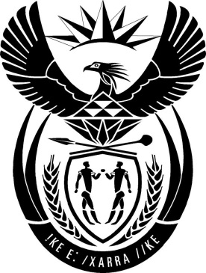

MINISTRY: PUBLIC SERVICE AND ADMINISTRATION

REPUBLIC OF SOUTH AFRICA

NATIONAL ASSEMBLY

QUESTION FOR WRITTEN REPLY

QUESTION NO: 1372

Mr J N de Villiers (DA) to ask the Minister of Public Service and Administration:

Whether his department did business with certain (a) persons, (b) companies and (c) trusts (names and details furnished in each case) (i) in each of the past five financial years and (ii) since 1 April 2019; if so, (aa) on what date(s) did his department do business with the specified persons, companies and trusts and (bb) what was the (aaa) nature and (bbb) monetary value of each business arrangement?
NW2585E
REPLY
The Department of Public Service and Administration (DPSA) has not done business with any of the persons, companies and or trusts as listed in any of the past five (5) financial years or since 1 April 2019.

