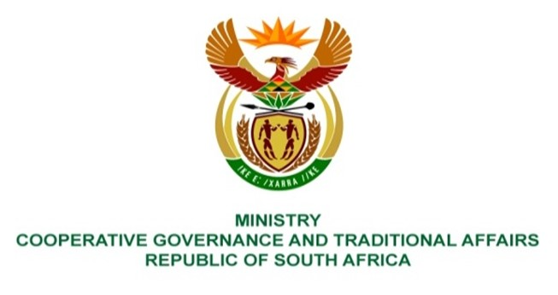

NATIONAL ASSEMBLY
QUESTIONS FOR WRITTEN REPLY

QUESTION NUMBER 1370
DATE OF PUBLICATION: 22 APRIL 2022
QUESTION:
1370. Ms P Marais (EFF) to ask the Minister of Cooperative Governance and Traditional Affairs:
By what date does she envisage the drainage problem in Mangaung will be fixed, as roads are flooded and water runs into residents’ houses each time it rains? NW1660E

REPLY

According to a report from the Mangaung Metropolitan Municipality (MMM), MMM has just finalized the appointment of a contractor to attend to the flooding spots as and when required.

It is however expected that the acting senior personnel, including the Acting Municipal Manager and Acting Engineering Services Head of Department, will ensure that service delivery plans are in place within three (3) months, budgeted for and implemented. The service delivery plans will provide timelines.

The Municipal Infrastructure Support Agent (MISA) will provide technical support to MMM with regard to infrastructure development and service delivery.

