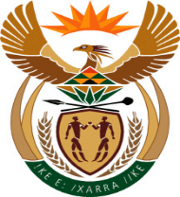

MINISTER IN THE PRESIDENCY: PLANNING, MONITORING AND EVALUATION
REPUBLIC OF SOUTH AFRICA
QUESTIONS FOR WRITTEN REPLY
FRIDAY, 6 February 2019

137. Mr Y Cassim (DA) to ask the Minister in The Presidency:
With reference to the reply of the Minister of Public Service and Administration to question 3797 on 21 December 2018, what was the total expenditure incurred by her Office relating to the travel privileges contained in the 2007 Ministerial Handbook of former (a)(i) Ministers and (ii) their spouses, (b)(i) Deputy Ministers and (ii) their spouses, (c) Ministers’ widows or widowers and (d) Deputy Ministers’ widows or widowers (i) in each of the past five financial years and (ii) since 1 April 2018?NW142E

REPLY
(a)(i) The Department did not incur expenditure relating to travel for the former Ministers nor (ii) their spouses (b) (i) former Deputy Ministers (ii) their spouses, (c) former Ministers’ widows or widowers and (d) former Deputy Ministers’ widows or widowers for the period in the question.

