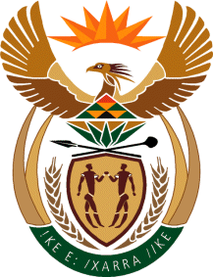

MINISTRY: COMMUNICATIONS
REPUBLIC OF SOUTH AFRICA
Private Bag X 745, Pretoria, 0001, Tel: +27 12 473 0164 Fax: +27 12 473 0585
Tshedimosetso House,1035 Francis Baard Street, Tshedimosetso House, Pretoria, 1000

NATIONAL ASSEMBLY
QUESTION FOR WRITTEN REPLY
QUESTION NUMBER: 137
DATE OF PUBLICATION: 9 FEBRUARY 2017

Ms V van Dyk (DA) to ask the Minister of Communications:
What steps is she taking to ensure that the disbursement of funds from the Media Development and Diversity Agency (MDDA) to its grant beneficiaries is not delayed, as was the case in the 2015-16 financial year, with specific reference to (a) the tranche release process and (b) reported noncompliance in respect of project reporting? NW142E

REPLY: MINISTER OF COMMUNICATIONS

- Based on critical assessment of each project we have revised disbursement to three or two tranches, however on new projects that require monitoring it is four tranches.
- The MDDA increased on-site capacity building and support on reporting, this includes close monitoring of those projects that delay reporting, projects that are non-compliant are visited and given necessary support on issues such obtaining tax clearance certificates, holding Annual General Meetings and challenges with financial management and reporting.

MR NN MUNZHELELE
DIRECTOR GENERAL [ACTING]
DEPARTMENT OF COMMUNICATIONS
DATE:

MS AF MUTHAMBI (MP)
MINISTER OF COMMUNICATIONS
DATE

