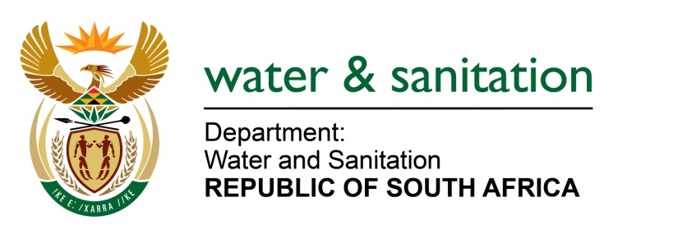

NATIONAL ASSEMBLY

FOR WRITTEN REPLY

QUESTION NO 1369

DATE OF PUBLICATION IN INTERNAL QUESTION PAPER: 21 May 2021
(INTERNAL QUESTION PAPER NO.14)

1369. Mrs M R Mohlala (EFF) to ask the Minister of Water and Sanitation:
What total amount has been paid to AURECON for their involvement in the Lesotho Highlands Water Project?
NW1562E
---00O00---

MINISTER OF WATER AND SANITATION

The total paid to AURECON SA thus far is R 236 205 932.
AURECON SA is participating in various Consulting Joint Ventures for the Lesotho Highlands Water Project as per shares and figures indicated in the schedule below.
Contract LHDA No. | Description | Contracted Party | Total Contract Amount (R) | Aurecon SA Share of Total Contract Amount (%)
3020 | Design and Supervision of Major Bridges | Aurecon Consortium | 123 892 049 | 30%
3022 | Design and Supervision of Polihali Diversion Tunnels | Metsi a Senqu Khubelu Consultants (MSKC) | 82 460 577 | 19.6%
3007 | Design and Supervision of Polihali Transfer Tunnel | Metsi a Senqu Khubelu Consultants (MSKC) | 914 276 029 | 20%
TOTAL |  |  |  | 21%

