THE MINISTER
RESPONSE TO PARLIAMENTARY QUESTION

Document Classification
Confidential | X
Secret
Top Secret

SUBJECT | RESPONSE TO NCOP QUESTION NUMBER ??

PQ NUMBER | 299
Date of Publication | 18/02/2022
Due to Parliament | 02/2022

Recommended By (via e-submission)
Post Level | Post | Name | Cell Number
Director
Chief Director

Recommended by Deputy Director General: LGSIM
Name | Signature | Date

Recommended by Director General: DCOG
Name | Signature | Date
Ms AA Williamson

Approved by Minister of Cooperative Governance and Traditional Affairs
Name | Signature | Date
Dr Nkosazana Dlamini Zuma, MP

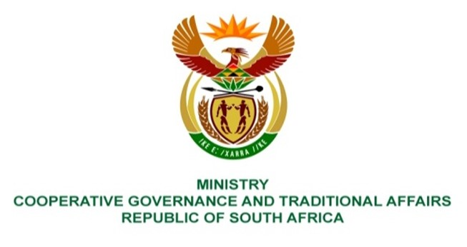

NATIONAL ASSEMBLY
QUESTIONS FOR WRITTEN REPLY

QUESTION NUMBER: PQ 1368
DATE OF PUBLICATION: 22 APRIL 2022

QUESTION:

1368. Mrs S M Mokgotho (EFF) to ask the Minister of Cooperative Governance and Traditional Affairs:
By what date does she envisage that basic services such as water and electricity will be provided to the community of Esdale in Ward 8 in the Kagisano-Molopo Local Municipality?

REPLY:
The response below were provided by the Kagisano-Molopo Local Municipality.
There is a plan in place for implementing the project in 2022/23 Municipal FY under the Bulk infrastructure cluster funded by DWS under RBIG. The Department of Water and Sanitation (DWS) has confirmed that the Engineers/Consultants are busy with the design and finalization of the technical report which will be presented to the department for approval of the funding under the 2022/23 Municipal Financial Year, which starts on the 01 July 2022.
With regards to electricity, Esdale village is electrified, However, there is few newly built homes which have not yet received electricity. The municipality applies every financial year to Eskom for electrification of infills and Esdale will be included in 2023/2024 municipal financial year.

