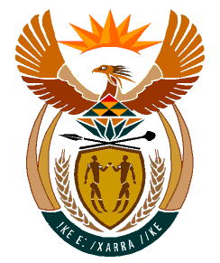

MINISTRY
HUMAN SETTLEMENTS
REPUBLIC OF SOUTH AFRICA

Private Bag X645, Pretoria, 0001. Tel: (012) 421 1309, Fax: (012) 341 8513

Private Bag X9029, Cape Town, 8000. Tel (021) 466 7603, Fax: (021) 466 3610

NATIONAL ASSEMBLY
QUESTION FOR WRITTEN REPLY
QUESTION NUMBER: PQ 1367 (NW1657E)
DATE OF PUBLICATION: 22 APRIL 2022

Ms. S M. Mogkotho ( EFF) asked the Minister of Human Settlements:

By what date does she envisage that her Department will provide housing to the community of ward 8 in Kagisano-Molopo Local municipality, following empty promises that were made to the residents by the specified municipality in 2016? NW1657E

REPLY
The Department including the North West Provincial Department of Human Settlements, is not aware of such a commitment made by the municipality. However, the Department will engage communities, and municipalities in order to undertake the necessary pre-planning and detailed planning processes, construct houses and thereafter allocate to qualifying beneficiaries.

