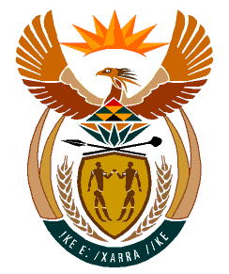

MINISTRY:
HUMAN SETTLEMENTS, WATER AND SANITATION
REPUBLIC OF SOUTH AFRICA

NATIONAL ASSEMBLY

QUESTION FOR WRITTEN REPLY

QUESTION NO.: 1366

DATE OF PUBLICATION: 25 OCTOBER 2019

Mr C Brink (DA) to ask the Minister of Human Settlements, Water and Sanitation:

Whether her department did business with certain (a) persons, (b) companies and (c) trusts (names and details furnished in each case) (i) in each of the past five financial years and (ii) since 1 April 2019; if so, (aa) on what date(s) did her department do business with the specified persons, companies and trusts and (bb) what was the (aaa) nature and (bbb) monetary value of each business arrangement? NW2579E

REPLY:

The Department of Human Settlements and the Department of Water and Sanitation have advised me that they have not done business with the companies referred to by the Honourable Member in the past five financial years and (ii) since 1 April 2019 to date.

