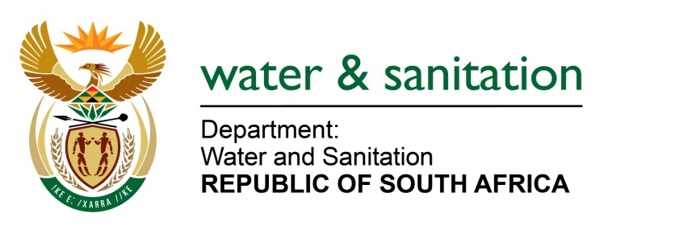

NATIONAL ASSEMBLY

FOR WRITTEN REPLY

QUESTION NO 1366

DATE OF PUBLICATION IN INTERNAL QUESTION PAPER: 13 MAY 2016
(INTERNAL QUESTION PAPER NO. 14)

1366. Mr A R McLoughlin (DA) to ask the Minister of Water and Sanitation:
Whether her department acquired any (a) hardware and/or (b) software information technology equipment in the (i) 2014-15 and (ii) 2015-16 financial years; if not, why not; if so, what are the full details in each case in terms of (aa) what were the tender requirements, (bb) where were the relevant tender advertisements placed, (cc) who were the members of each bid adjudication committee, (dd)(aaa) where and (bbb) when did each of the specified bid adjudication committees sit, (ee)(aaa) how many tender applications were received for each advertised tender and (bbb) from whom, (ff) who was the successful bidder in each case and (gg) on what basis was each tender awarded to the specified successful bidder? NW1514E
---00O00---
REPLY:

Refer to the table below for the summary of the acquired hardware and software for the periods in question:

 | (i) 2014-15 financial years | (ii) 2015-16 financial year
(a) Hardware | My Department awarded three (3) tenders for the acquisition of hardware | My Department awarded three (3) tenders for the acquisition of hardware
(b) Software | No tenders were awarded for acquisition of software | My Department awarded four (4) tenders for the acquisition of software

The specific details for the tenders awarded for the acquisition of hardware and software during the period in question is detailed in Annexure A.

---00O00---

