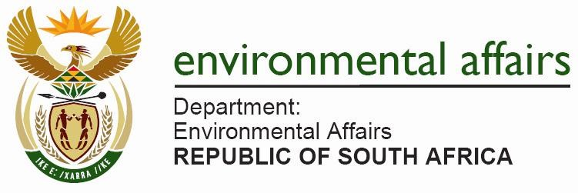

NATIONAL ASSEMBLY
(For written reply)

QUESTION NO. 1360 {NW2573E}
INTERNAL QUESTION PAPER NO. 22 of 2019

DATE OF PUBLICATION: 25 October 2019

Ms A L A Abrahams (DA) to ask the Minister of Environmental Affairs, Forestry and Fisheries

Whether her department did business with certain (a) persons, (b) companies and (c) trusts (names and details furnished in each case) (i) in each of the past five financial years and (ii) since 1 April 2019; if so, (aa) on what date(s) did her department do business with the specified persons, companies and trusts and (bb) what was the (aaa) nature and (bbb) monetary value of each business arrangement?

1343. THE MINISTER OF ENVIRONMENT, FORESTRY AND FISHERIES REPLIES:

a) b) c) i) ii) The Department did not do any business with the relevant persons, companies and trusts for the past five financial years and current financial year.

aa) Not applicable.

bb) aaa) bbb) Not applicable.

Regards
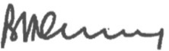
MS BD CREECY, MP
MINISTER OF ENVIRONMENT, FORESTRY AND FISHERIES
DATE: 07 November 2019

NATIONAL ASSEMBLY QUESTION NO. 1360 NW2573E

