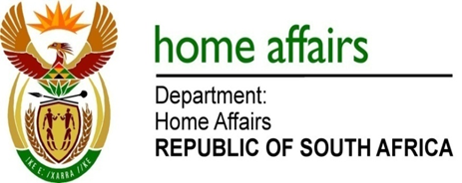

NATIONAL ASSEMBLY

QUESTION FOR WRITTEN REPLY

QUESTION NO. 1360

DATE OF PUBLICATION: FRIDAY, 4 MAY 2018

INTERNAL QUESTION PAPER 14 OF 2018

1360. Mrs Dreyer (DA) to ask the Minister of Home Affairs:

What number of foreign nationals (a) entered South Africa in 2017 on (i) visitor visas and/or (ii) holiday visas, (b) departed on or before the date on which their visas expired and (c) of each nationality (i) did not depart and (ii) applied for asylum? NW1462E

REPLY:

(a)(i-ii) 15,083,238 total recorded movements for traveller arrivals in 2017 on visitor’s visas for holiday purposes.

(b) 16,181,312 total recorded movements for traveller departures in 2017. The difference between arrivals and departures could arise as a carryover of movements from 2016.

(c)(i) The top five nationalities whose movements indicate they have not yet departed the RSA are:

1. Zimbabwe: 227 365
2. Malawi: 66 742
3. Mozambique: 47 031
4. Lesotho: 38670
5. Swaziland: 4 549

(c)(ii) 24,174 applications for asylum were received in the 2017 calendar year.

