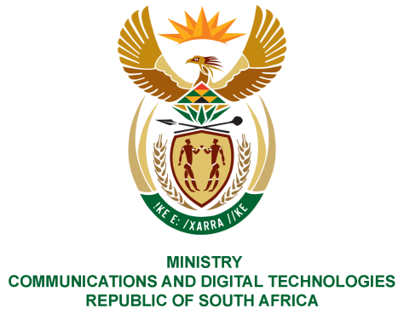
PARLIAMENT OF THE REPUBLIC OF SOUTH AFRICA
NATIONAL ASSEMBLY
WRITTEN REPLY

QUESTION NO: 1358
DATE OF PUBLICATION: 14 MAY 2021
QUESTION PAPER NO: 15
Mr Z N Mbhele (DA) to ask the Minister of Communications:
Whether, with regard to the preparations of the SA Broadcasting Corporation (SABC) for the coverage of the upcoming 2021 local government elections, and with reference to the mandate and obligations of the SABC as the national public broadcaster to educate and inform the public, the SABC will be broadcasting any practical and specific public education content related to municipal governance, especially with reference to sections 151 to 164 of the Constitution of the Republic of South Africa, 1996, as well as its Schedules 4 and 5; if not, why not; if so, what are the relevant details?
NW1554E
REPLY:

I have been advised by the SABC as follows:

Yes, public education has historically formed part of the SABC’s standard elections coverage mandate and will continue to do so during this current election cycle. The SABC News will drive this process from an editorial perspective as has always been the case post democracy with covering and contextualizing the elections, Constitution and functioning of municipalities.

MS. STELLA NDABENI-ABRAHAMS, MP
MINISTER OF COMMUNICATIONS AND DIGITAL TECHNOLOGIES

