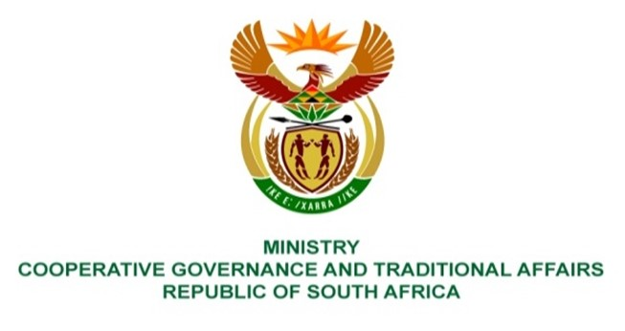

NATIONAL ASSEMBLY
QUESTION FOR WRITTEN REPL
QUESTION NUMBER 1357
DATE OF PUBLICATION: 22 APRIL 2022

QUESTION:

1357: Ms P Madokwe (EFF) to ask the Minister of Cooperative Governance and Traditional Affairs:

Whether she has the power to take steps against those accountable for failing to make payments throughout the years to Eskom, noting that a number of municipalities in the Free State owe Eskom millions of rand, despite collecting cash from communities over the years and as a result communities such as Ward 18 in the Dihlabeng Local Municipality have been without electricity for weeks, despite the specified municipality verifying that the total sum due to Eskom has been paid as they have been on prepaid electricity for years in which case they owe Eskom no money; if not, what recourse do communities, who are being penalised as a result of government incompetence, have in order to address the specified issue; if so, what steps does she intends to take? NW1645E

REPLY:

In terms of section 139(7) of the Constitution of the Republic of South Africa, 1996, the national executive must intervene in terms of section 139(4) or (5) if the provincial executive cannot or does not adequately exercise the powers or perform the functions referred to in subsection 139(4) or (5) of the Constitution.

The Department of Cooperative Governance (DCoG), as part of the Inter-Ministerial Task Team (IMTT) chaired by the Deputy President, His Excellency Mr David Mabuza, on electricity with the Department of Public Enterprises (DPE), National Treasury (NT), the South African Local Government Association (SALGA), Eskom and the Department of Energy (DE), is leading a responsible citizenry campaign to educate consumers on the benefits of paying for municipal services and rates. All Departments are also required to support the campaign by ensuring that they settle their debt with municipalities. Stakeholder engagements have been undertaken with various municipalities to discuss the support and the institutionalisation of the campaign in each municipality.

In line with the Inter-governmental Relations Framework Act, the Department appointed inter-governmental dispute resolution facilitators in all provinces to deal with inter-governmental disputes and to process and verify the amount of debt owed by organs of state to municipalities, and in turn the debt owed by municipalities to Eskom and water boards.

