NATIONAL ASSEMBLY

QUESTION NO. 1355-2021
WRITTEN REPLY
INTERNAL QUESTION PAPER NO. 13 –2021, DATE OF PUBLICATION 14 MAY 2021:
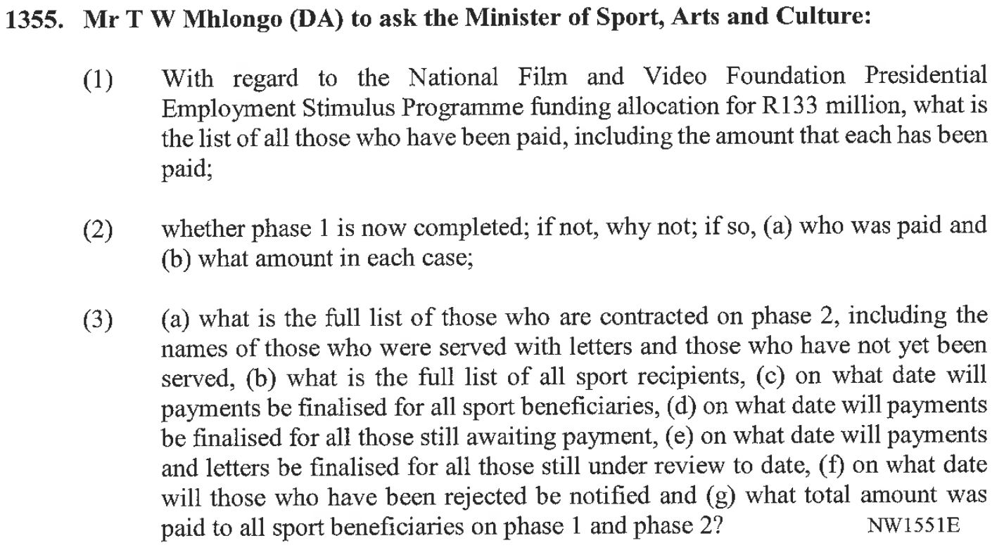
REPLY:
- The list of paid beneficiaries of the Presidential Employment Stimulus Programme that is being rolled out by the National Film and Video, inclusive of the amount is attached as requested.
- PESP Phase 1 of the National Film and Video Foundation is not yet completed and it is envisaged that it will be concluded by the end of June 2021. The list of beneficiaries paid is the same as the one provided in question 1 above.
- PESP phase 2 has not started. No approval for implementation has been granted yet by the National Treasury.

Presidential Employment Stimulus Programme
Split | Allocation | Paid to date | Balance available | Jobs proposed | Jobs projected | Jobs outstanding
Stream 1 | 84 534 772,00 | 58 764 484,00 | 25 770 288,00 | 6 375 | 5 838 | 537
Stream 2 | 22 513 038,00 | 22 263 038,00 | 250 000,00 | 1 200 | 1 187 | 13
Stream 3 | 12 950 000,00 | 12 950 000,00 | - | 705 | 705 | -
Stream 4 | 13 002 190,00 | 10 502 190,24 | 2 499 999,76 | 675 | 480 | 195
Admin | 7 000 000,00 | 4 531 324,12 | 2 468 675,88
Total | 133 000 000,00 | 104 479 712,24 | 28 520 287,76 | 8 955,00 | 8 210,00 | 745,00

