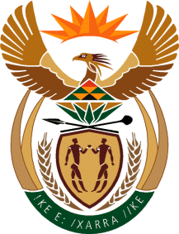

MINISTRY OF TOURISM
REPUBLIC OF SOUTH AFRICA

Private Bag X424, Pretoria, 0001, South Africa. Tel. (+27 12) 444 6780, Fax (+27 12) 444 7027
Private Bag X9154, Cape Town, 8000, South Africa. Tel. (+27 21) 469 5800, Fax: (+27 21) 465 3216

NATIONAL ASSEMBLY:

QUESTION FOR WRITTEN REPLY:
Question Number: 1353
Date of Publication: 26June 2020
NA IQP Number: 23
Date of reply: 05 September 2020

Mr M S F de Freitas (DA) to ask the Minister of Tourism:
Whether the implementation of the Tourism Equity Fund, to which the President of the Republic of South Africa, Mr M C Ramaphosa, referred to in the State of the Nation Address on 13 February 2020, will be unfrozen post Covid-19; if not, what (a) other support mechanisms does her department have to help the sector get back on its feet and (b) are the (i) time frames, (ii) timelines and (iii) deadlines in this regard? NW1723E

REPLY:
The implementation of the TEF was impacted upon by the reprioritisation of government’s budget and has had to be temporarilyput on hold. Given the significance of the Fund in relation to the transformation of the tourism sector, its implementation will continue going forward.

(a) and (b) The implementation of the Tourism Equity Fund is continuing.

