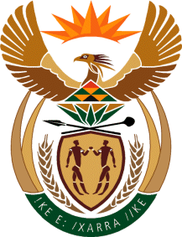

MINISTRY: COMMUNICATIONS
REPUBLIC OF SOUTH AFRICA
Private Bag X 745, Pretoria, 0001, Tel: +27 12 473 0164 Fax: +27 12 473 0585
Tshedimosetso House,1035 Francis Baard Street, Tshedimosetso House, Pretoria, 1000

NATIONAL ASSEMBLY
QUESTION FOR WRITTEN REPLY
QUESTION NUMBER: 1350
DATE OF PUBLICATION: MAY 2016

Dr A Lotriet (DA) to ask the Minister of Communications:
Whether a certain person (name furnished) who holds two positions at the Media Development and Diversity Agency (details furnished) receives two salaries for holding the specified positions; if not, what is the position in this regard; if so, what are the relevant details? NW1498E

REPLY: MINISTER OF COMMUNICATIONS
There are no MDDA staff members who receive more than one salary. The MDDA has 4 x staff members who occupy permanent positions and have been appointed in acting positions according to the Human Resources Acting in a Higher Position policy. These positions are in the process of being filled. These employees receive an acting allowance for temporarily acting in higher positions.

MR NN MUNZHELELE
DIRECTOR GENERAL [ACTING]
DEPARTMENT OF COMMUNICATIONS
DATE:

MS AF MUTHAMBI (MP)
MINISTER OF COMMUNICATIONS
DATE:

