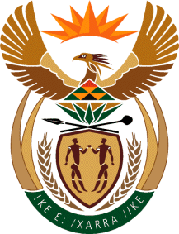
MINISTRY: SPORT AND RECREATION
REPUBLIC OF SOUTH AFRICA

Private Bag X869, Pretoria, 0001, Tel: (012) 304 5158, Fax: (012) 323 8426
Private Bag X9149, Cape Town, 8000, Tel: (021) 465 5506/7/8/9, Fax: (021) 465 4402

135. Mr T W Mhlongo (DA) to ask the Minister of Sport and Recreation:

(1) Whether he has signed a Memorandum of Understanding (MoU) between his department and the Spanish La Liga Football Division; if not, why not; if so, on what date was it signed;

(2) whether he will provide Mr T W Mhlongo with the full contents of the MoU; if not, why not; if so, by what date? NW140E

REPLY
we still confirming with legal office regarding information about the memorandum of agreement. Information is not readily available

​​

