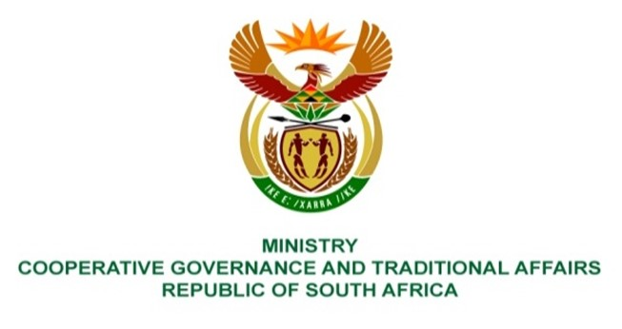

NATIONAL ASSEMBLY
QUESTIONS FOR WRITTEN REPLY

QUESTION NUMBER 1348
DATE OF PUBLICATION: 21 APRIL 2023

QUESTION:

1348. Ms H Ismail (DA) to ask the Minister of Cooperative Governance and Traditional Affairs:

(1) Given that most municipalities are currently experiencing major water shortages, with residents continuously having to suffer with either extreme low water pressure or no water at all, by what date will an inter-governmental task team be set up to deal with the water crisis;

(2) whether, in light of the fact that municipalities are the ones that are severely impacted by the water crisis and considering that a state of disaster has been declared due to the load shedding crisis, she has found that municipalities must ensure that all our residents have access to an uninterrupted water supply; if not, what is the position in this regard; if so, what are the relevant details in this regard;

(3) what are the reasons that Rand Water reservoirs and all other water reservoirs and/or feeds and systems are not exempt from load shedding, as this directly impacts the supply of water to residents? NW1550E
REPLY:
The Inter-governmental task team dealing with water challenges is lead by Department of Water and Sanitation. Moreover, Rand Water is accountable to DWS as Water Utility. It is therefore recommended that the question be redirectred to Ministry of Water and Sanitation to provide responses accordingly.

End.

