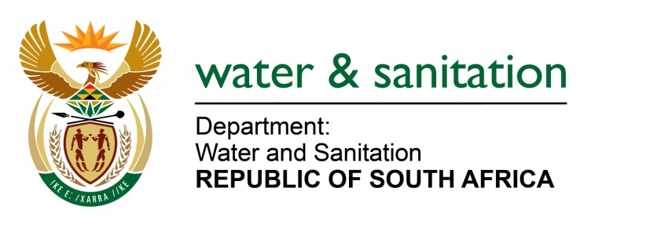

NATIONAL ASSEMBLY

FOR WRITTEN REPLY

QUESTION NO 1347

DATE OF PUBLICATION IN INTERNAL QUESTION PAPER: 21 APRIL 2023
(INTERNAL QUESTION PAPER NO. 13)

1347. Ms H Ismail (DA) to ask the Minister of Water and Sanitation:
With Gauteng and other provinces currently experiencing major water shortages and residents continuously having to suffer with either extremely low water pressure or no water at all, what are the detailed steps that have been taken to ensure that Rand Water has the additional funds for (a) upgrading and (b) improving water infrastructure?
NW1549E
---00O00---

MINISTER OF WATER AND SANITATION
Gauteng has been experiencing water shortages in recent weeks. Water supply interruptions have largely been a function of unstable electricity supply as well as incidents of vandalism. Rand Water has always maintained that their infrastructure capacity is sufficient to meet the current real demand. Nevertheless, Rand Water has ringfenced R42 billion to rehabilitate and augment their infrastructure. Rand Water has sufficient funding headroom to fund this programme and does not require additional government funding yet.
The improvement of supply is being ensured through engagements with Eskom and other electricity suppliers. To this extent, Rand Water is also implementing their own strategies towards an energy mix approach which includes hydropower generation, photovoltaic and installation of generators to mitigate the risk of energy supply. These initiatives are all underway and being implemented.

---00O00---

