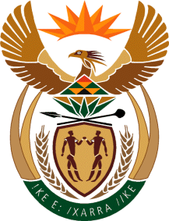

MINISTRY: COMMUNICATIONS
REPUBLIC OF SOUTH AFRICA
Private Bag X 745, Pretoria, 0001, Tel: +27 12 473 0164 Fax: +27 12 473 0585
Tshedimosetso House,1035 Francis Baard Street, Tshedimosetso House, Pretoria, 1000

NATIONAL ASSEMBLY
QUESTION FOR WRITTEN REPLY
QUESTION NUMBER: 1346
DATE OF PUBLICATION: MAY 2016

Ms V van Dyk (DA) to ask the Minister of Communications:
(1) Whether the Media Development and Diversity Agency (MDDA) has ever used any broadcasting funds to support the small commercial print media; if not, what is the position in this regard; if so, (a) who authorised the usage of the specified funds to support small commercial print media and (b) will she make the relevant documents reflecting the relevant information available; (2) whether the MDDA reflected the usage of broadcasting funds to support small commercial print media in its annual financial statements for any relevant financial year; if not, why not; if so, in which financial years; (3) whether the MDDA has ever reported in Parliament any usage of broadcasting funds to support small commercial print media; if not, (a) why not and (b) who took the decision not to include the specified usage in its reports to Parliament; if so, in which documents were such usage(s) reported? NW1494E

REPLY: MINISTER OF COMMUNICATIONS

(1) No.
(2) As stated above the MDDA has not used any Broadcast funds to support the small commercial media.
(3) As stated above the MDDA has not used any Broadcast funds to support the small commercial media.

MR NN MUNZHELELE
DIRECTOR GENERAL [ACTING]
DEPARTMENT OF COMMUNICATIONS
DATE:

MS AF MUTHAMBI (MP)
MINISTER OF COMMUNICATIONS
DATE:

