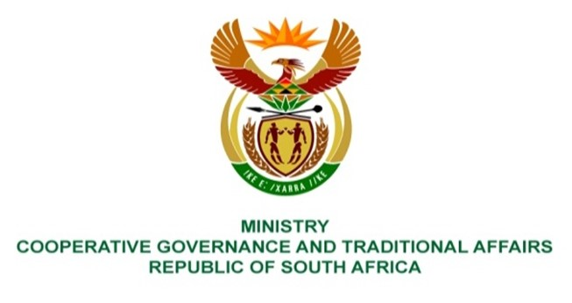

NATIONAL ASSEMBLY
QUESTIONS FOR WRITTEN REPLY

QUESTION NUMBER: 2021/1327
DATE OF PUBLICATION: 14 MAY 2021

QUESTION:

1345. Ms E R J Spies (DA) to ask the Minister of Cooperative Governance and Traditional Affairs:

(1) Whether, with reference to the oversight visit of the Portfolio Committee on Cooperative Governance and Traditional Affairs to the waste water treatment plant in the Naledi Local Municipality in the North West on 6 May 2021, (a) she has been informed of allegations made by officials of the specified municipality that the operation of the plant has been outsourced to a service provider that is completely incapable of fulfilling the relevant licencing conditions, leading to the pollution of natural water sources; if not, why not; if so,

(2) whether she intends to take steps to ensure that there is co-operation between stakeholders such as the North West provincial government, the municipality and the district municipality in respect of ensuring access to potable water by the community and the proper functioning of the waste water treatment plant in the Naledi Local Municipality; if not, what is the position in this regard; if so, what are the relevant details? NW1541E

REPLY:
My department requested the North West Provincial department, and the line department for sanitation to provide a detailed report in relation to question raised by the honourable member. MISA will provide the necessary technical support. The reply will be updated with the information as it becomes available.

BACKGROUND INFORMATION:

