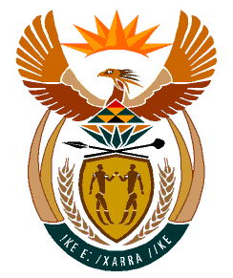

MINISTRY
HUMAN SETTLEMENTS
REPUBLIC OF SOUTH AFRICA

Private Bag X645, Pretoria, 0001. Tel: (012) 421 1309, Fax: (012) 341 8513

Private Bag X9029, Cape Town, 8000. Tel (021) 466 7603, Fax: (021) 466 3610

QUESTION FOR WRITTEN REPLY
QUESTION NUMBER: PQ 134

DATE OF PUBLICATION: 09 February 2023

134. Mr N Singh (IFP) to ask the Minister of Human Settlements:
In light of the fact that electric geysers are usually the highest electricity consuming appliances in homes accounting for about 30% to 40% of electricity used, what are the full details of the (a) roll-out of solar geysers to date, (b) feedback on their effectiveness and (c) plans and timeframes of the roll-out of solar geysers going forward? NW138E

REPLY:

The Department of Human Settlements received the Parliamentary question, reviewed it against its mandate and has determined that the best respondent is the Department of Minerals and Energy

