THE MINISTER
RESPONSE TO PARLIAMENTARY QUESTION

Document Classifrication
Confidential | X
Secret
Top Secret

SUBJECT | RESPONSE TO NATIONAL ASSEMBLY QUESTION NUMBER ……..

PQ NUMBER | 1339
Date of Publication | 14 May 2021
Due to Parliament | 28 May 2021

Recommended By (via e-submission)
Post Level | Post | Name | Cell Number
Director | Director | Clive Maduna | 072 314 0753
Chief Director

Recommended By Deputy Director General: LGSIM
Name | Signature | Date
Mr T Fosi

Recommended By Director General: DCOG
Name | Signature | Date
Ms AA Williamson

Approved by Minister of Cooperative Governance and Traditional Affairs
Name | Signature | Date
Dr Nkosazana Dlamini Zuma, MP

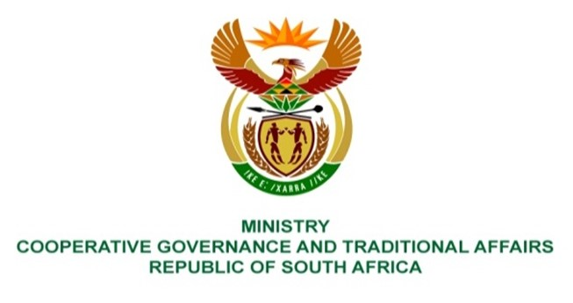

NATIONAL ASSEMBLY
QUESTIONS FOR WRITTEN REPLY

QUESTION NUMBER 1339
DATE OF PUBLICATION: 14 May 2021

QUESTION: Whether, with regard to her replies to question 587 on 26 March 2021 and 1013 on 33 June 2017, she will clarify the discrepancy, wherein the 2017 reply it is that a backlog for resurfacing and rehabilitation of roads was 2 500km and/or R11,25 billion, yet in the 2021 reply the figure was 1 352km and/or R3,1 billion; if not, why not; if so, what total amount, in each year, between 2017 and 2021 did her department spend on resurfacing and rehabilitation of roads, to warrant such a drastic decrease? NW1535E

REPLY:

The Parliamentary Question PQ 587, with its reply provided on 26 March 2021, is similar to PQ 194. The reply to PQ 194, which is attached as part of the annexure, was submitted to Parliament.

I have requested the Provincial Department to furnish further details of work done during the period in question. We will make this information and anys supporting ducuments available to the honourable member.

