THE NATIONAL ASSEMBLY

QUESTION FOR WRITTEN REPLY

QUESTION NO. 1333

DATE PUBLISHED: 14 MAY 2021

Mr G R Krumbock (DA) to ask the Minister of Trade, Industry and Competition:

(1) (a) What are the names of all the approved service providers, including those responsible for events, catering, and marketing, for the National Lottery Board and (b) on what date was each service provider appointed.

(2) what (a) payments were made to each service provider in the (i) 2016-17, (ii) 2017-18, (iii) 2018-19 and (iv) 2019-20 financial years and (b) services were rendered with regard to each payment? [NW1529E]

REPLY

I have been furnished with a reply to the question submitted, by Ms Thabang Mampane, Commissioner of the National Lotteries Commission.

“(1)(a)(b) The panel for service providers relating to the promotion of public knowledge and awareness by, amongst others developing and implementing educational and informational measures to educate the public of the Lotteries about the lotteries and provisions pursuant to section 2(5)(a)(i) of the Lotteries Act - Operations: Brand Positioning, Grant Funding and Regulated matters. Catering for the organisation was procured in line with relevant PFMA, Treasury Regulations and National Treasury guidelines as follows:

OPERATIONAL COSTS PURSUANT TO SECTION 2(5) OF THE LOTTERIES ACT, NO 57 OF 1997
2016/17 Financial Year | 2017/18 Financial Year | 2018/19 Financial Year | 2019/20 Financial Year
Name of Service Provider Contract Start Date  Tsalena Media 15-Jul-14 | No panel appointed. | Name of Service Provider Contract Start Date  Anzomode 1-Oct-18  Tau Ya Phoka (Pty) Ltd 1-Oct-18  Roadshow Marketing 1-Oct-18  Cheniwell 1-Oct-18  Khanya PR and Media (Pty) Ltd 1-Oct-18  Chilo Group 1-Oct-18  Be- Sure Events Solutions (Pty) Ltd 1-Oct-18  Black Moon Advertising and Research (Pty) Ltd 1-Oct-18 | Name of Service Provider Contract Start Date  Anzomode 1-Oct-18  Tau Ya Phoka (Pty) Ltd 1-Oct-18  Roadshow Marketing 1-Oct-18  Cheniwell 1-Oct-18  Khanya PR and Media (Pty) Ltd 1-Oct-18  Chilo Group 1-Oct-18  Be- Sure Events Solutions (Pty) Ltd 1-Oct-18  Black Moon Advertising and Research (Pty) Ltd 1-Oct-18

(2) (a)(i)(ii)(iii)(iv) and (b)
OPERATIONAL COSTS PURSUANT TO SECTION 2(5) OF THE LOTTERIES ACT, NO 57 OF 1997
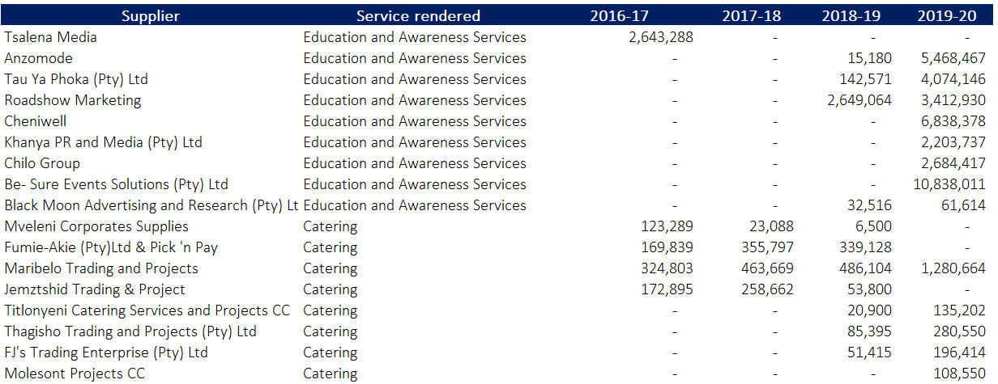

It is noteworthy to mention that the following suppliers provided education and awareness as it relates to Education and Awareness publication costs as per PQ466, and it is our understanding that the current PQ seeks to gather information relating to Education and Awareness workshop and conferencing costs.

- Anzomode
- Tau ya Phoka (Pty) Ltd
- Roadshow Marketing
- Chilo Group (Pty) Ltd
- Cheniwell
- Be-Sure Events Solutions (Pty) Ltd
- Blackmoon Advertising and Research (Pty) Ltd.”

-END-

