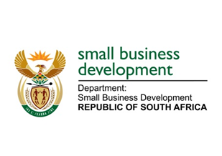
NATIONAL ASSEMBLY
QUESTION FOR WRITTEN REPLY
DUE TO PARLIAMENT: FRIDAY, 28 MAY 2021

1332. Mr H C C Krüger (DA) to ask the Minister of Small Business Development:
Whether she has formally submitted the final justification and draft legislation regarding the merger of the Small Enterprise Finance Agency and the Small Enterprise Development Agency into a single entity to the Minister of Public Service and Administration and the Minister of Finance for consultation and inputs; if not, why not; if so, what are the relevant details? NW1528E
_________________________________________________________________________________
REPLY:

The business case has been submitted to the relevant Ministers for inputs. The Department is currently taking the draft business case through government structures to get Cabinet endorsement on the preferred option first before finalisation of the business case which will then be followed by the drafting of the relevant legislation.

_______________________________________________________________________________
RESPONSE RECOMMENDED BY:

_______________________
MR LINDOKUHLE MKHUMANE
ACTING DIRECTOR GENERAL: DEPARTMENT OF SMALL BUSINESS DEVELOPMENT
DATE:
______________________________________________________________________________
RESPONSE RECOMMENDED BY:

________________________
MS ROSEMARY CAPA, MP
DEPUTY MINISTER OF SMALL BUSINESS DEVELOPMENT
DATE:

_______________________________________________________________________________
RESPONSE APPROVED BY:

_________________________
MS KHUMBUDZO NTSHAVHENI, MP
MINISTER OF SMALL BUSINESS DEVELOPMENT
DATE:

