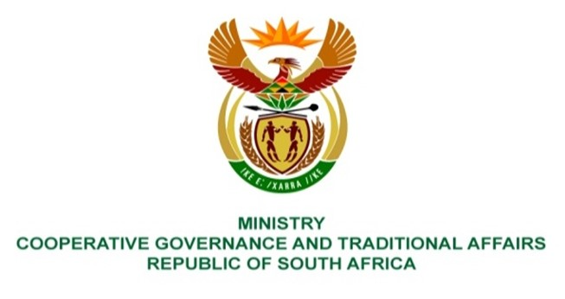

NATIONAL ASSEMBLY
QUESTIONS FOR WRITTEN REPLY

QUESTION NUMBER 1330
DATE OF PUBLICATION: 14 MAY 2021

QUESTION:

1330. Ms A M M Weber (DA) to ask the Minister of Cooperative Governance and Traditional Affairs:

QUESTION:
(a) (1) With regard to the waste water treatment plants in Ekurhuleni, what is the (a) waste water treatment capacity in megalitres of each plant in Ekurhuleni and (b) current waste water inflow in megalitres of each waste water treatment plant in Ekurhuleni;
(2) whether all discharge points from each waste water plant are tested; if not, why not; if so, what is the frequency of testing in each plant;
(3) what are the details of the discharge water test results of each waste water treatment plant for the (a) 2019-20 and (b) 2020-21 financial years;
(4) what steps were taken to increase waste water treatment capacity in Ekurhuleni since 2011?
NW1526E

REPLY:
The information requested from the Honourable Member has been requested from Ekurhuleni Metro Municipality and the Provincial Departments concerned, we will update the response upon receipt of the information.

