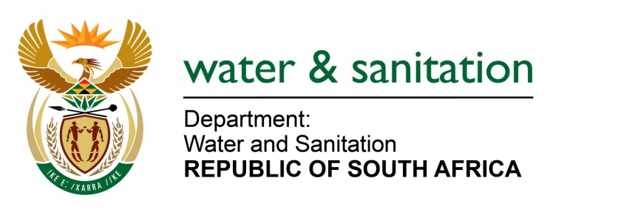

NATIONAL ASSEMBLY

FOR WRITTEN REPLY

QUESTION NO 133

DATE OF PUBLICATION IN INTERNAL QUESTION PAPER: 09 FEBRUARY 2017
(INTERNAL QUESTION PAPER NO. 1)

133. Ms T E Baker (DA) to ask the Minister of Water and Sanitation:

With regard to the Amathole District Municipality project to build toilets in villages in the district, (a) when did the project begin, (b) what are the details of the progress of the project, (c) how many toilets have been built thus far and (d) what are the (i) current and (ii) projected costs of the project? NW138E
---00O00---
REPLY:

(a) Amathole District Municipality appointed a service provider for the sanitation project on 1 September 2014.
(b) To date, of 66 700 Units, a total to some 30 409 Units are completed whilst 36 291 Units are still outstanding.
(c) Refer to (b) above.
(d)(i) The current estimated cost is R 288 064 457, 00.
(d)(ii) The projected cost to complete the project is R508m which includes payments of invoices not paid to service providers.
---00O00---

