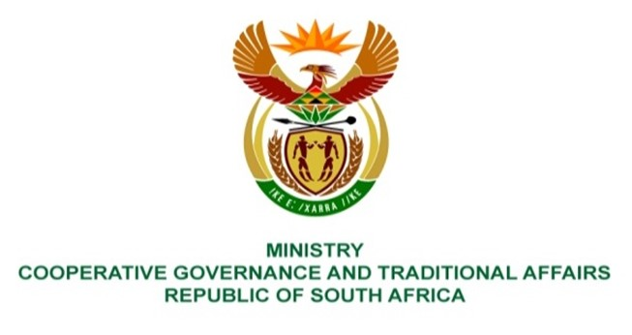

NATIONAL COUNCIL OF PROVINCES
QUESTIONS FOR WRITTEN REPLY

QUESTION NUMBER 1327/2021
DATE OF PUBLICATION: 28 May 2021

PQ NO 1327/2021. Mr C. Brink (DA) to ask the Minister of Cooperative Governance and Traditional Affairs:

QUESTION:
What is the current status of the (a) Local Government Leadership Academy and (b) Municipal Leadership Development Programme launched by the erstwhile Department of Provincial and Local Government in 2007? NW1523E

REPLY:
- The Local Government Leadership Academy (LOGOLA) was established in 2004 as the initiative of the then Department of Provincial and Local Government (dplg). Its developmental objective was to contribute towards the development of a broad base of politically mature leadership that can sustain democracy and strengthen a sustainable developmental local government sphere in South Africa. The LOGOLA model proposed in the Concept Paper was too expensive to implement, although by 2007 it was accredited by LGSETA as a virtual training provider to facilitate the Municipal Leadership Development Programme (MLDP). The academy was since disestablished during the Department’s transitional process in 2010, which also planned for the revitilisation of LOGOLA towards the establishment of a School for Local Government that in the future would merge with the National School of Government.

- After its launch in 2007, the Municipal Leadership Development Programme (MLDP), and given that the overall concept was too expensive to implement, it was agreed that a focus on councillors training would be subjected to a number of pilots facilitated by accredited service providers. Approximately, 286 councillors and senior managers were enrolled in the pilot programme although in many cases the Portfolio of Evidence was not timeously completed in those four municipalities. The programme was since discontinued in 2010 as part of the envisaged reconcptualisation of LOGOLA.

