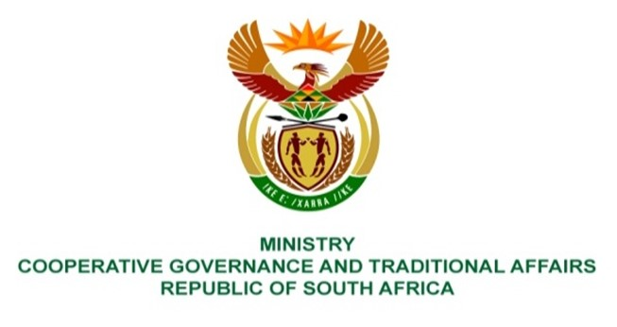

NATIONAL ASSEMBLY
QUESTIONS FOR WRITTEN REPLY

QUESTION NUMBER 1325
DATE OF PUBLICATION: 14 May 2021

Mr C Brink (DA) to ask the Minister of Cooperative Governance and Traditional Affairs:

- Whether, with reference to a meeting of the Portfolio Committee on Cooperative Governance and Traditional Affairs held on 1 April 2021, wherein an official from her department indicated that a review of the Intergovernmental Relations Framework Act, Act 13 of 2005, is currently underway to enable the Government to implement the District Development Model (DDM)(details furnished), she has found that certain provisions of the existing legislation will hinder the implementation of the DDM; if not, what is the position in this regard; if so, what are the legislative provisions concerned;

- Whether a review of legislation is currently underway to facilitate the implementation of the DDM; if not, why not; if so, what are the details of the review process? NW1521E

REPLY:

- The District Development Model (DDM) as a approach towards ensuring improved intergovernmental coordination and cooperation is premised on utlising enabling levers within existing legislation, policies, and experiences within the government and non governmental space. The Intergovernmental Relations Act, 13 of 2005 (IGRFA), is one such piece of legislation that contains several enabling provisions that are used to frame the design, institutionalisation, and implementation of the DDM. More specifically section 47. Currently Regulations as required and specified under section 47(1)(b) of the IGRFA are being drafted that will, once gazetted and approved provide a legal framework for the institutionalisation and implementation of the DDM. The draft Regulations as it stands is a culmination of extensive intergovernmental consultations and dialogues that were facilitated by my Department over the course of the 2020/21 financial year. Further consultations and dialogues will continue during the 1st quarter of this financial year that will provide further insights to the strengthening and finalisation of the Regulations.

- Constant dialogues on the relevance and impact of the Intergovernmental Relations Framework Act, 13 of 2005, have been facilitated by my Department since 2015 (marking the 10 years of enactment of the Act), which were also complimented by various research studies. One key finding that came out from these studies and dialogues was a need to review the Act as a whole in order to discern which sections are still relevant, which sections need to be refined,and what additional sections could be added in a amended Act. At the end of the 2020/21 financial year a discussion document outlining several proposals for amendment was produced through several intergovernmental dialogues, which will continue during the course of the 1st and 2nd quarters of this financial year. The build-up and collected experiences gained from the implementation of the DDM will therefore compliment the review of the IGRFA where needed for future implementation. It therefore should be indicated that the review have been undertaken before the advent of the DDM as a continuos process.

