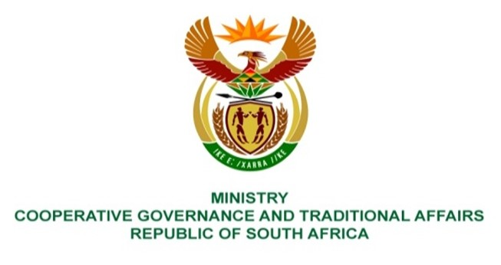

NATIONAL ASSEMBLY
QUESTIONS FOR WRITTEN REPLY

QUESTION NUMBER 1323
DATE OF PUBLICATION: 21 APRIL 2023

QUESTION:

1323. Ms B Mathulelwa (EFF) to ask the Minister of Cooperative Governance and Traditional Affairs:
Which assistance has been provided to the community of Umhlabuyalingana who lost their land to the Isimangaliso Wetland Park? NW1488E

REPLY:
This question should be responded to by the Department of Rural Development and Land Reform.

End.

