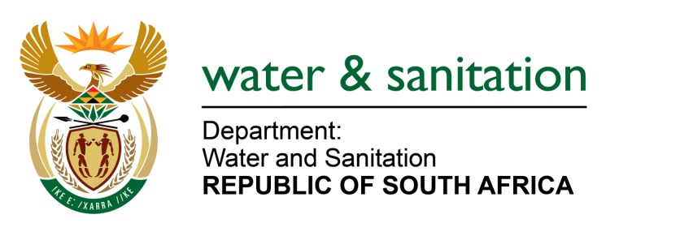

NATIONAL ASSEMBLY

FOR WRITTEN REPLY

QUESTION NO 1319

DATE OF PUBLICATION IN INTERNAL QUESTION PAPER: 21 APRIL 2023
(INTERNAL QUESTION PAPER NO. 13)

1319. Mrs M R Mohlala (EFF) to ask the Minister of Water and Sanitation:
In light of his limited interventions within the intergovernmental relations framework, what other options are available to mitigate the total collapse of the bulk water and sanitation infrastructure in the Republic?
NW1484E
---00O00---
MINISTER OF WATER AND SANITATION
The reliability of municipal water and sanitation services is generally deteriorating, evidenced by the Green Drop and Blue Drop assessments. To mitigate the total collapse of services/infrastructure, the Department of Water and Sanitation (DWS) is strengthening its regulatory role over municipal water and sanitation services.
During this financial year we will be consulting on updated and more comprehensive norms and standards for water and sanitation services, in terms of the Water Services Act. We will also publish a National Regulatory Dashboard showing the extent of compliance with the national norms and standards for water services for all Water Service Authorities, drawing on existing monitoring information. We are also in the process of introducing standardised regulatory enforcement protocols to be implemented by all our regional offices, to make our regulatory actions more consistent.
One of the underlying causes of the decline in municipal water services, both in terms of the reliability of service delivery and in terms of financial sustainability, is the non-implementation of certain key requirements of the Water Services Act by municipalities. The Act distinguishes between Water Services Authorities and Water Service Providers and requires municipalities to separately manage and account for the roles of Water Services Authority and Water Services Provider. It further requires Water Services Authorities to ensure that Water Service Providers provide access to efficient and sustainable water services to everyone. Almost all Water Service Authorities have been failing to do this.
To address this, we are considering introducing some amendments to the Water Services Act, with the aim of further clarifying the roles, responsibilities and functions of Water Services Authorities and Water Services Providers; setting minimum standards for the functioning of Water Services Providers which must be enforced by Water Services Authorities; and providing the Minister with powers to regulate these matters. We will be consulting on these proposed amendments with a view to taking them through the cluster system to Cabinet during this financial year.

---00O00---

