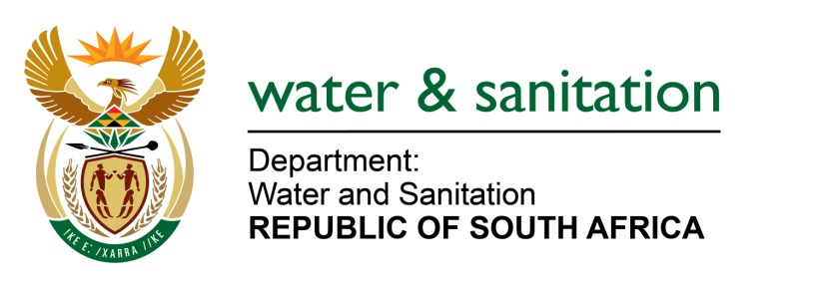

NATIONAL ASSEMBLY

FOR WRITTEN REPLY

QUESTION NO 1318

DATE OF PUBLICATION IN INTERNAL QUESTION PAPER: 21 APRIL 2023
(INTERNAL QUESTION PAPER NO. 13)

1318. Dr S S Thembekwayo (EFF) to ask the Minister of Water and Sanitation:
Whether (a) bulk water and (b) sanitation infrastructure are listed as national priority areas in his department; if not, why not; if so, (i) how will they be managed and (ii) what are the projected total costs thereof?
---00O00---

MINISTER OF WATER AND SANITATION
(a-b) It is the responsibility of the Department of Water and Sanitation (DWS) to ensure adequate water availability through the development and management of infrastructure for water resources, as well as enhance the provision of sustainable and reliable water supply and sanitation by local government. The responsibility to supply water and sanitation services lies with municipalities that are Water Services Authorities (WSAs). Regional Bulk infrastructure is provided and managed through Water Boards as water providers.

To deliver on its mandate, the DWS’ plans for water and sanitation services are to:
- Implement 25 large bulk infrastructure projects over the medium term.
- Supporting 44 district municipalities with developing water and sanitation reliability plans over the medium term.
- Assess annual municipal strategic self‐assessments across all WSAs authorities on an ongoing basis.
- Transfer funds and monitor the performance of municipalities that receive funds through the regional bulk infrastructure grant and water services infrastructure grant in terms of the annual Division of Revenue Act.

The DWS monitors the condition of municipal water and sanitation infrastructure through three incentive-based regulatory mechanisms:

- The Green Drop Report, which focuses on sanitation (waste-water treatment systems and effluent quality).
- The Blue Drop Report, which focuses on water (water treatment and water quality).
- The No Drop Report, which focuses on non-revenue water and water losses through leakages.

- There are several initiatives underway to improve the management of water and sanitation countrywide which include the following:
- National Government will ensure that grant funding in the water sector is allocated with the objective of restoring functionality of existing wastewater infrastructure according to the findings of the Green and Blue Drop reports. VROOM-informed restoration-focussed grant management will be effected with support from National Treasury.
- DWS as a Regulator will improve the implementation of Section 19 of the National Water Act (Act 36 of 1998) to ensure that directives are issued with timeframes for implementation. Failure to respond will trigger remedial action being taken at cost of the non-complying entity or municipality.
- DWS will take steps to improve its capacity to be more effective in this duty. There are engagements with the Department of Cooperative Governance as well as National Treasury to explore ways of utilising conditional grants for the purpose of remedial intervention.

- The DWS has allocated R23billion from the Regional Bulk Infrastructure Grant and R15bn from the Water Services Infrastructure Grant over the medium term. The purpose of the grants is to provide financial support to municipalities to:
- Build new bulk water and sanitation infrastructure.
- Refurbish and upgrade ageing infrastructure.
- Provide secondary bulk infrastructure (new or augmentation projects).
- Develop sources such as boreholes and spring protection.
- Implement water conservation and water demand management projects.

---00O00---

