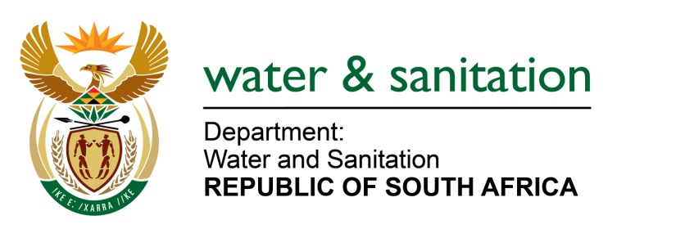

NATIONAL ASSEMBLY

FOR WRITTEN REPLY

QUESTION NO 1317

DATE OF PUBLICATION IN INTERNAL QUESTION PAPER: 21 APRIL 2023
(INTERNAL QUESTION PAPER NO. 13)

1317. Mrs M R Mohlala (EFF) to ask the Minister of Water and Sanitation:
What (a) number of directives have been issued against transgressing municipalities that fail to manage sewage and effluent polluting major water sources for the period 2021 to date and (b) is the breakdown of the (i) directives issued, (ii) consequences thereof and (iii) follow-up assessments in each province?
NW1482E
---00O00---
MINISTER OF WATER AND SANITATION
- Since January 2021 to date, a total of eighty-three (83) directives have been issued by the Department of Water and Sanitation (DWS) against municipalities that have failed to manage sewage and causing pollution.

- (i) The table below depicts a breakdown of the directives issued per province.
Enforcement Actions taken against non-compliant Municipalities *since January 2021 to date
Responsible Regional Office | *NWA Notices Issued | NWA Directives Issued
Eastern Cape | 10 | 8
Free State | 6 | 7
Gauteng | 20 | 18
KwaZulu Natal | 21 | 1
Limpopo | 11 | 13
Mpumalanga | 39 | 22
North-West | 5 | 5
Northern Cape | 30 | 8
Western Cape | 12 | 1
Total | 154 | 83
(ii) The consequences of DWS’ enforcement actions are indicated below:
- Five criminal charges laid against municipalities because of non-compliance with the Directives issued.
- Two (2) criminal charges were laid and finalised against Randfontein and Thaba Chweu Local Municipality whereby both municipalities pleaded guilty of all the charges. Both municipalities were subsequently fined by the courts for their failure to adhere to the provisions of NWA, among other violations.
- Three cases were referred to National Persecuting Authority for a decision. The Department has initiated three court interdict applications against the non-compliant municipalities, seeking Court Orders from the courts.
(iii) The DWS conducted forty-nine follow-up inspections whereby compliance with the provisions of the Notices and Directives is established.
---00O00---

