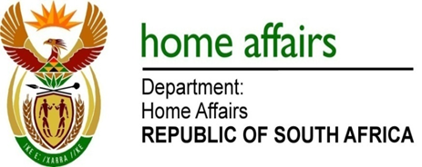

NATIONAL ASSEMBLY

QUESTION FOR WRITTEN REPLY

QUESTION NO. 131

DATE OF PUBLICATION: THURSDAY, 7 FEBRUARY 2019

INTERNAL QUESTION PAPER 1 OF 2019

131. Ms H Bucwa (DA)) to ask the Minister of Home Affairs:

With reference to the reply of the Minister of Public Service and Administration to question 3797 on 21 December 2018, what was the total expenditure incurred by his department relating to the travel privileges contained in the 2007 Ministerial Handbook of former (a)(i) Ministers and (ii) their spouses, (b)(i) Deputy Ministers and (ii) their spouses, (c) Ministers’ widows or widowers and (d) Deputy Ministers’ widows or widowers (i) in each of the past five financial years and (ii) since 1 April 2018? NW136E

Reply:

I am advised by the Department that this question was asked to the Former Minister as question 1821 of 2018. I refer the Honorable Member to the same answer.

