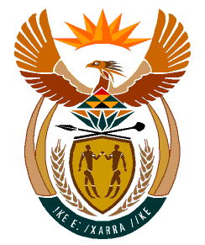

MINISTRY:
HUMAN SETTLEMENTS, WATER AND SANITATION
REPUBLIC OF SOUTH AFRICA

NATIONAL ASSEMBLY

QUESTION FOR WRITTEN REPLY

QUESTION NO.: 1308

DATE OF PUBLICATION: 25 OCTOBER 2019

Ms E L Powell (DA) to ask the Minister of Human Settlements, Water and Sanitation:

With reference to her reply to question 813 on 4 October 2019, (a) where is each of the 167 land parcels located and (b) what is the size of each land parcel? NW2520E

REPLY:

(a) & (b) Due to sensitivities around possible land invasions, the Department of Humans Settlements cannot publicise the location and the sizes of the 167 land parcels earmarked for release by the Department of Public Works and Infrastructure. It is important to note that the properties have been prioritised for release and subsequent development for human settlement purposes at the request of various Municipalities, Provinces and the Housing Development Agency (HDA).

