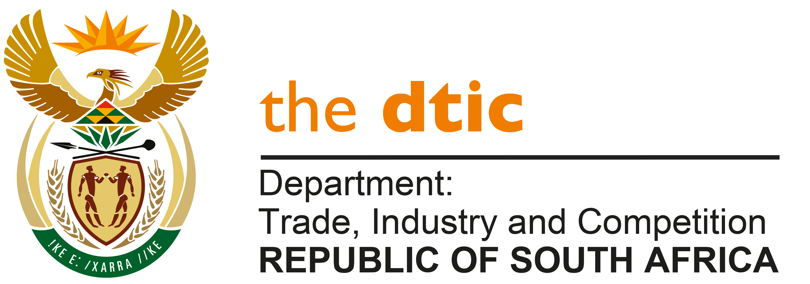

THE NATIONAL ASSEMBLY

QUESTION FOR WRITTEN REPLY

QUESTION NO. 1306

DATE PUBLISHED: 14 MAY 2021

Mr M J Cuthbert (DA) to ask the Minister of Trade, Industry and Competition:
- On what date was the internal report into corruption in the National Lotteries Commission by Sekela Xabiso audit firm due to be completed;
- (a) what are the reasons that the report has not yet been presented to the Portfolio Committee on Trade, Industry and Competition and (b) on what date will the report be presented to the specified committee;
- what amount has been paid to the specified audit firm thus far;
- whether he will furnish Mr M J Cuthbert with a detailed breakdown of the R36,5 million budgeted for the investigation in question; if not, why not; if so, what are the relevant details? [NW1500E]

REPLY

The Department of Trade, Industry and Competition (the dtic) did not appoint Sekela Xabiso to conduct an investigation. The company was appointed by the NLC and attached herewith is the response from the NLC regarding the matter. Below is the reply to the question, submitted by Ms Thabang Mampane, Commissioner of the National Lotteries Commission.

- “The Board of the NLC initiated the investigation by offering members of the public an unrestricted platform to report any acts of wrongdoing, corruption or fraud through the appointed independent audit firm and to provide all evidence, notwithstanding those matters previously independently investigated and concluded. The investigation was expected to be concluded by end of May 2020; however, the due date fell within the period of the Level 5 hard lockdown. Thus due to COVID-19 restrictions, the inability to travel to conduct site visits and/or verification of infrastructure projects, the voluminous matters to be investigated and many other factors that led to a delay in the work of the audit firm gaining momentum the initial conclusion date was not met as anticipated.

- The investigation process is underway and final outcomes of the investigation pending. The Board will make available the final outcomes of the investigation upon conclusion and adoption by the Board, as previously undertaken to the Portfolio Committee.

- The total cost of the investigation to date is R9,657,867.10.

- In responding to the question, extract of NLC’s response provided on PQ 695 bears reference.

Extract of PQ 695

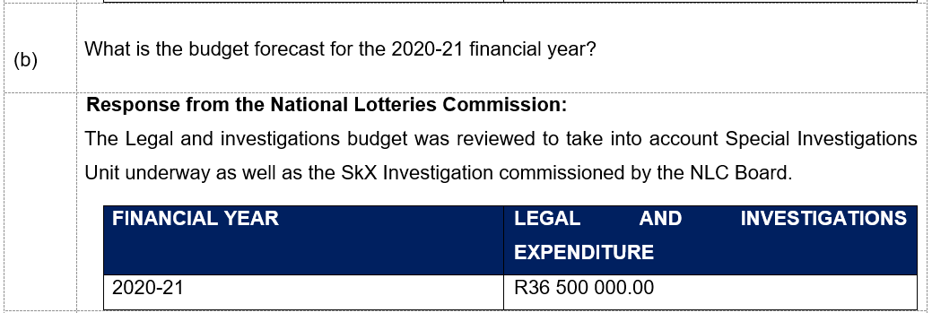

The National Lotteries Commission is required to fulfil its mandate and ensure that the Commission performs its functions efficiently and effectively in compliance with the Lotteries Act and any other applicable law. The budget spend over the past three financial years to ensure that the NLC provides guidance and support to the Board whilst applying the principles of openness and transparency to advise the Minister on the efficacy of legislation pertaining to lotteries and ancillary matters, exercise its power to institute legal proceedings in order to properly discharge its functions and responsibilities and approach any court for any order the board deems appropriate for effective regulation and enforcement of the Lotteries Act is detailed below. The rapid increase of the Legal and Investigations budget over the past three years is attributed to independent investigations as a result of increased media exposure and enforcement of the Third National Lotteries Licence, pursuant to ensuring that the National Lottery and Sport Pools are conducted with all due propriety and strictly in accordance with the Constitution, the Act, all other applicable law.

The total budget allocated for Legal & Investigations Division was R36 500 000.00, being 2% of its National Lotteries Commission’s total expenditure including Grant Allocations.”

-END-

