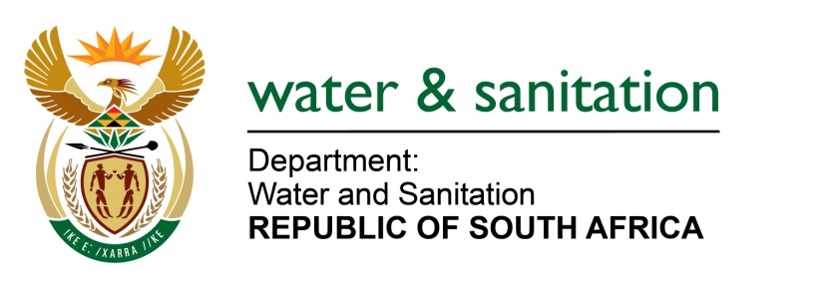

NATIONAL ASSEMBLY

FOR WRITTEN REPLY

QUESTION NO 1304

DATE OF PUBLICATION IN INTERNAL QUESTION PAPER: 17 APRIL 2015
(INTERNAL QUESTION PAPER NO. 10)
1304. Mrs Z B N Balindlela (DA) to ask the Minister of Water and Sanitation:
What steps is her department taking to prevent raw sewerage flowing from Kwa-Thatha through Phaphamani into the Belmont Valley in Makana Municipality? NW1513E
---00O00---
REPLY:
Requesting that the Honorable Member to refer to the response to NA 1305.
---00O00---

