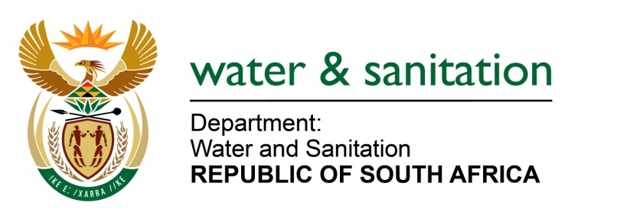

NATIONAL ASSEMBLY

FOR WRITTEN REPLY

QUESTION NO 1302

DATE OF PUBLICATION IN INTERNAL QUESTION PAPER: 04 APRIL 2022
(INTERNAL QUESTION PAPER NO. 13)

1302. Mr C Brink (DA) to ask the Minister of Water and Sanitation:
Whether she has been advised that many households in the formalised Section D of Botshabelo in Ward 38 of the Mangaung Metropolitan Municipality still use bucket toilets and that the toilets are not serviced by the municipality on a regular basis; if not, what action does she intend to take in this regard in terms of section 154(1) of the Constitution of the Republic of South Africa, 1996, to assist the municipality to provide the households with access to flush toilets; if so, what measures are being taken by local, provincial and national government to provide the specified households with access to flush toilets? NW1561E

---00O00---
MINISTER OF WATER AND SANITATION

The Department does not fund Metropolitan Municipalities for water and sanitation programmes since such municipalities receive the Urban Settlement Development Grant (USDG) from the Department of Human Settlements (DHS).

The USDG is intended to fund programmes related to the Built Environment for the provision of basic municipal services, including water and sanitation infrastructure.

The Department of Water and Sanitation engaged with Mangaung Metropolitan Municipality (MMM) about short-medium term plans towards the eradication of bucket toilets in Section C of Botshabelo in Ward 32 and obtained the following report:

- Botshabelo is affected by bulk sanitation constraints. The main outfall sewer needs an upgrade at an estimated cost of R60 million. Additionally, the wastewater treatment works needs to be upgraded from its current capacity of 20Ml/d to 40Ml/d at an estimated cost of R380 million.

- The current hydraulic load at the WWTW is 18ML/d, which means that there is a spare capacity of 2ML/d. The upgrade of the main outfall sewer is expected to be completed by December 2023. The project to eradicate bucket toilets in Botshabelo Section D is planned for the 2022/23 financial year. The current bulk sanitation spare capacity is adequate to accommodate the additional imposed demand caused by the planned upgrade.

- MMM plans to install an upgradable alternative sanitation solution as a short-term measure to overcome bulk challenges. A budget of R94.5 million has been appropriated for the programme under USDG over the Medium-Term Expenditure Framework period. A total of 5 300 units will be constructed and later converted to a full waterborne system after installation of the bulk infrastructure. The project is at the procurement stage and awaiting the National Treasury directive on procurement matters due to the constitutional court finding on the PPPFA.

---00O00---

