NATIONAL ASSEMBLY
36/11411(201900014)

FOR WRITTEN REPLY QUESTION 13
DATE OF PUBLICATION IN INTERNAL QUESTION PAPER: 7 FEBRUARY 2019 (INTERNAL QUESTION PAPER NO 1-2019)

13. Dr P J Groenewald (FF Plus) to ask the Minister of Police:
- What number of radio towers linking the number 10111 with police stations are currently out of order in each province;

- (a) what is the reason for each tower being out of order in each case and (b)
when it will be repaired?

REPLY:
NW17E

(1) The 10111 number is not linked via South African Police Service (SAPS) Radio Towers to police stations. The 10111 number is connected to the Telkom infrastructure and there are currently no reported incidents of disruptions affecting Telkom’s infrastrucure.
(2)(a) Not applicable.

(2)(b) Not applicable.

Reply to question 13 recommended

L C
OLE (SOEG)
GENERAL
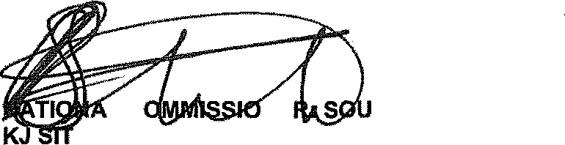
NE TH AFRICAN POLICE SERVICE

2

Reply to question 13 approved/
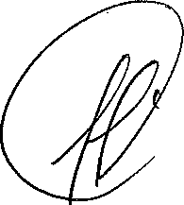
MINISTER OF POLICE BH CELE, MP

30/1/4/1(201900025)
NATIONAL ASSEMBLY

FOR WRITTEN REPLY QUESTION 246
DATE OF PUBLICATION IN INTERNAL QUESTION PAPER: 15 FEBRUARY 2019 (INTERNAL QUESTION PAPER NO 2•2019)

246. Mr S P Mhlongo (EFF) to ask the Minister of Police:

Whether there has been any arrests by the SA Police Service with regard to currency manipulatlon of the Rand that has been uncovered by the Competition Commission investigation; if not, what is the position in this regard; if so, what are the relevant details?
NW257E
REPLY:

The Directorate for Priority Crime Investigation (DPCI) is not investigating any matter in relation to the currency manipulation of the Rand.

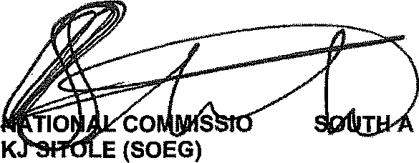
Reply to question 246 recommended/

NER:
GENERAL FRICAN POLICE SERVICE

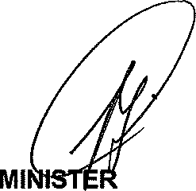
Reply to question 246 approved/

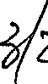
OF POLICE BH CELE, MP

Date: & O
/

