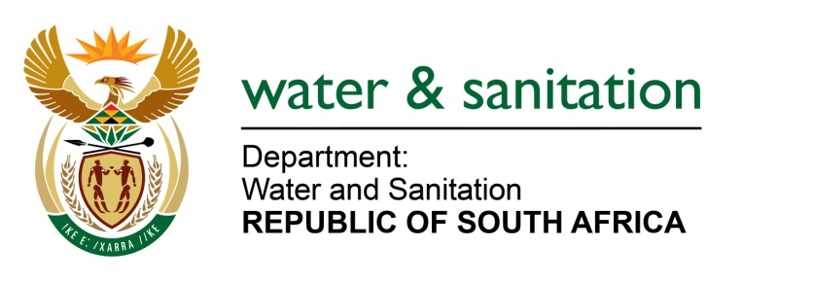

NATIONAL ASSEMBLY

FOR WRITTEN REPLY

QUESTION NO 1296

DATE OF PUBLICATION IN INTERNAL QUESTION PAPER: 21 APRIL 2023
(INTERNAL QUESTION PAPER NO. 13)

1296. Mr K Ceza (EFF) to ask the Minister of Water and Sanitation:
What steps of intervention has he taken with regard to the water-scarce area of the Victor Khanye Local Municipality? NW1460E
---00O00---

MINISTER OF WATER AND SANITATION

The Victor Khanye Local Municipality is supported by the Department of Water and Sanitation (DWS) through the Water Services Infrastructure Grant (WSIG) to implement Water Conservation and Water Demand Management (WCWDM) projects to reduce non-revenue water.

The DWS approved funding of R68 million over a period of three financial years (2022/2023 -2024/2025) to be allocated to the municipality for the WCWDM projects. The intended outcomes are:
- To reduce water losses in Botleng Ext. 3 to 7
- Ensure that water is supplied to Botleng Ext. 3 to 7 through the reconfiguration of existing pipelines and installation of new pipelines to address the intermittent water supply
- Ensure installation of water meter in every household
- Management of different water pressure in the water supply systems in Botleng Ext. 3 to 7
- Raise awareness on water conservation.

---00O00---

