Ministry
Employment & Labour
Republic of South Africa
Private Bag X499, PRETORIA, 0001. Laboria House 215 Schoeman Street, PRETORA Tel: (012) 392 9620 Fax: 012 320 1942
Private Bag X9090, CAPE TOWN, 8000. 120 Plein Street, 12th Floor, CAPE TOWN Tel: (021) 466 7160 Fax 021 432 2830
www.labour.gov.za

NATIONAL ASSEMBLY

WRITTEN REPLY

QUESTION NUMBER: 1295 [NW1459E]

1295. Mr K Ceza (EFF) to ask the Minister of Employment and Labour:
What (a) local economic activities have recently been developed in rural municipalities such as the (i) Dr J S Moroka Local Municipality, (ii) Ngqushwa Local Municipality, (iii) Victor Khanye Local Municipality, (iv) Emakhazeni Local Municipality, (v) City of Matlosana Local Municipality, (vi) Maluti-a-Phofung Local Municipality and (vii) Nkomazi Local Municipality to discourage the influx of job seekers into urban areas and (b) is the time frame in this regard? NW1459E
REPLY:
PUBLIC EMPLOYMENT SERVICES

Public Employment Services (PES) is established by Section 5 of the Employment Service Act of 2014.

- The Department of Employment and Labour must render the following services free of charge to members of the public:
- Register work seekers on ESSA (Employment Services System of South Africa).
- Register learning or work opportunities received from employers.
- Match work seekers to opportunities and produce qualifying work seekers as per criteria requested by employers.
- Facilitate the placement of the work seekers into opportunities.
- Provide career counselling, life skills, psychometric assessments, and employability enhancements.
- Regulate private employment agencies
- Make recommendations to DHA before work visas are issued.

2 Labour centres in the Free State fall under Maluti-a- Phofung Local municipality. For the 2022/2023 financial year, their performance on registration of work and learning opportunities is as displayed below:

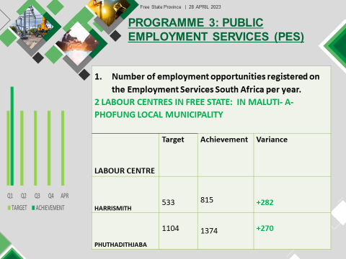

From the opportunities registered in 2022/2023 financial year. The 2 Labour centres placed work seekers into work and learning opportunities as displayed below:
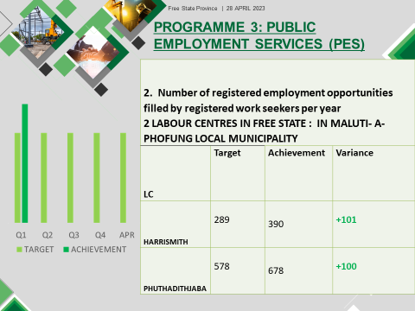

LABOUR ACTIVATION PROGRAMME:

- 2 Companies were assisted for BUSINESS TURN AROUND AND RE-ENGINEERING: MALUTI- A- PHOFUNG LOCAL MUNICIPALITY
- ENTRAKO(PTY) LTD: 75 Jobs were Preserved and 14 new employees were appointed. Overall 89 jobs were preserved.
- ENTRAWOOD CC: 115 Jobs were preserved and 4 were created. Overall 119 jobs were preserved.

MEMORANDUM OF UNDERSTANDING

- The PES embarks to build upon a partnership strategy involving prospective actors in the labour market with the common objective to reduce unemployment, poverty and inequality in South Africa.
- This Memorandum of Understanding (MoU) aims to create a partnering- relationship between The Department of Employment and Labour through its Public Employment Services branch and stakeholders in order to promote co-operation and achieve employment objectives
- In 2022/2023 financial year, the department of Employment and Labour has entered into Memorandum of understanding with two stakeholders in the Maluti-a- Phofung Local municipality:
- MALUTI TVET COLLEGE
- MALUTI –A – PHOFUNG LOCAL MUNICIPALITY

Eastern Cape

It is very important to note that the Department of Employment and Labour does not create employment opportunities or develop Local Economic activities for job seekers but creates an enabling environment for a labour market that is conducive to investment, economic growth, employment creation and decent work. This is done by partnering with other Government Departments, Local Government, Government Entities including Institutions of Higher Learning and Private Sector in support of initiatives that assist in bringing in investment, economic growth, employment creation and decent work in the labour market and that is done through the main services as provided by the Department’s Public Employment Services (PES) as follows:
• Work seeker registration – Registration of work seeker in the Employment Services South Africa (ESSA) database
• Employment Counselling – Empowerment of work seekers with job hunting and job readiness counselling programmes
• Recruitment and Selection – Registration of employment and learning opportunities received from employers with the purpose of recruiting suitable candidates from the ESSA databased based on the selection criteria specified by the employer
• Placement – Placement of suitable candidates into registered job or learning opportunities based on the employers’ selection preference using the ESSA system.
• Labour Activation Programme (LAP) – UIF funded programme aimed at funding labour activation initiatives for training and placement of UIF beneficiaries back into the labour market.

(a) In Ngqushwa Local Municipality, through the Labour Activation Programme funding was awarded to Walter University, 50 young people have been skilled in Animal Production and New Venture Creation with the purpose of encouraging self-sustainability and self-employment with potential to develop into entrepreneurship and employment of other young people. The 50 young people were recruited from the villages of Ngqushwa Local Municipality.
For this financial year 2023/2024, Ngqushwa Local Municipality, through its Local Economic Development Unit, is going to partner with the Department in recruitment, selection and placement of young people in their approved planned projects as per their IDP which are as follows:
• Bee keeping and honey processing
• Livestock movement project with feedlot and abattoir
• Training of young people in Traffic related opportunities
• Life guards for the 42km coastal area
These young people from all the villages of Ngqushwa Local Municipality will be encouraged to register in the ESSA database so that they can be recruited and placed in these opportunities. The ESSA database ensures that only people from that particular municipality are recruited according to the specification of the employer. The selected young people will also be provided with work ethics training and other life skills training such as financial management skills.
The Department continuously engages with other social partners to ensure more opportunities are marketed to local young people ensuring that they benefit from opportunities in their regions thus avoiding their influx into urban areas.

(b) The identified project and partnership is for this current financial year i.e. 2023/2034

City of Matlosana Local Municipality
The Department of Employment and Labour through its Labour Activation Programme (LAP) implement various projects to enhance the employability of the unemployed, to enable entrepreneurship and preserve jobs by integrating the unemployed people back to the labour market. This is achieved through entering into partnerships with both private and public sector entities to implement job creation initiatives and training of the unemployed and underemployed for the purpose of re-integrating them with labour market and economic transformation.

In the City of Matlosana, the LAP has implemented the following interventions since 2021:

Sector | Intervention | No. of Learners | Area of Training | Employer | Project Status
MICT SETA | Learnership | 27 | Film and TV Production | Platinum NW TV | Completed in 2021
MICT SETA | Learnership | 3 | System Support | 52 Benji | Completed in 2021
MICT SETA | Learnership | 1 | System Support | Sediko Primary School | Completed in 2021
MICT SETA | Learnership | 1 | System Support | Hotspot Café Internet and Business Solution | Completed in 2021
MICT SETA | Learnership | 1 | System Support | REX Building | Completed in 2021
THENSA(Technological Higher Education Network South Africa) | Learnership | 9 | Environmental Practice | A & P Scrap Metal Paper and Waste | Project put on hold in 2021 due to contractual issues. To resume in 2023
TOTAL |  | 42

The following interventions are in the pipeline for implementation during 2023/2024 financial year

Sector | Area | No. Learners | Project Status
Media | Matlosana | 300 | Submission on route for DG approval
Agriculture | Matlosana | 7000 | Submission on route for DG approval
Hospitality, Sports, Media, Health, Textile | Matlosana | 1000 | Submission on route for DG approval
Total |  | 8300

In addition, the DEL through Public Employment Services (PES), plays a significant role in coordinating programmes that contribute towards the reduction of unemployment, poverty and inequality across four districts in the North West Province. For the City of Matlosana, 1770 work seekers have been placed on various opportunities through the PES Programme since 2017:

Placement Opportunity Type | Sector | Area | No. Workseekers
Formal Job | Various | Matlosana | 588
Internship | Various | Matlosana | 46
Learnership | Various | Matlosana | 243
Projects | Various | Matlosana | 867
Total |  |  | 1770

