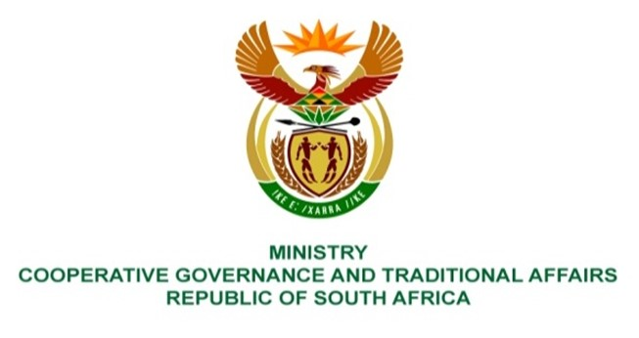

NATIONAL ASSEMBLY
QUESTION FOR WRITTEN REPLY
QUESTION NUMBER 1293
DATE OF PUBLICATION: 21 APRIL 2023

1293. Ms P Madokwe (EFF) to ask the Minister of Cooperative Governance and Traditional Affairs:
What (a) progress has been made by her department with the investigation into the corruption that took place in the Dr A B Xuma Local Municipality, where millions of rands that were meant to build a stadium were misused and (b) are the reasons that it has taken so many years for the specified investigation to be concluded and those implicated to be held accountable? NW1455E
REPLY:
The Eastern Cape Province's Department of Cooperative Governance and Traditional Affairs submitted the response listed below. I've been given the following advice as a result:
(a) The MEC established a team to investigate the allegations at Dr AB Xuma Local Municipality. The team visited the municipality to conduct an investigation from 11 to 15 July 2022, and conducted interviews with relevant officials; analysed documentation and obtained evidence. A report was thereafter prepared for consideration by the MEC.

(b) Limitations in terms of the scope of the investigation caused delays in the investigation. Due to the fact that most of those implicated are no longer with the municipality, the office of the MEC referred the matter to the South African Police Service (SAPS), to allow SAPS to deal with the matter.
End.

