THE MINISTER
RESPONSE TO PARLIAMENTARY QUESTION

Document Classifrication
Confidential | X
Secret
Top Secret

SUBJECT | RESPONSE TO NATIONAL ASSEMBLY QUESTION NUMBER 1285

PQ NUMBER | 1285
Date of Publication | 21 April 2023
Due to Parliament | 09 May 2023

Recommended By (via e-submission)
Post Level | Post | Name | Cell Number

Recommended By ACEO: MISA
Name | Signature | Date
Ms P Kgomo

Recommended by Director-General: DCoG
Name | Signature | Date
Mr. M Tshangana

Approved by Deputy Minister of Cooperative Governance and Traditional Affairs
Name | Signature | Date
Mr. P. Tau, MP

Approved by Minister of Cooperative Governance and Traditional Affairs
Name | Signature | Date
Ms Thembi Nkadimeng

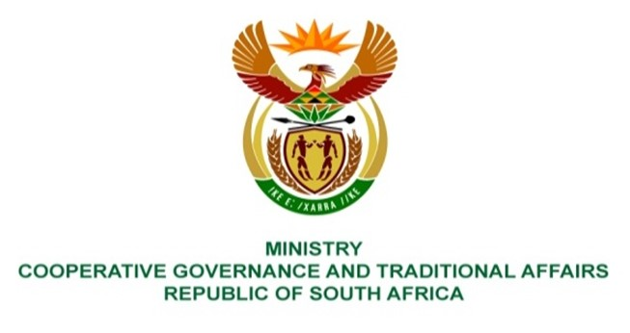

NATIONAL ASSEMBLY
QUESTIONS FOR WRITTEN REPLY
QUESTION NUMBER: 1285
DATE OF PUBLICATION: 21 APRIL 2023

1285. Ms H O Mkhaliphi (EFF) to ask the Minister of Cooperative Governance and Traditional Affairs:
Whether (a) her department and/or (b) any of the entities reporting to her have any current contracts with the security company G4S; if not, what is the position in this regard; if so, what (i) are the relevant details of the specified contracts and (ii) is the monetary value of each contract?
REPLY
(a/b) No, Department of Cooperative Governance and Traditional Affairs (COGTA) does not have any current contract with the security company G4S. Security service in the department (COGTA) is provided by Prime African Security and (MISA) is provided by TPD Security Services. All the companies were procured through a public tender.

- and (ii) Not applicable

End.

