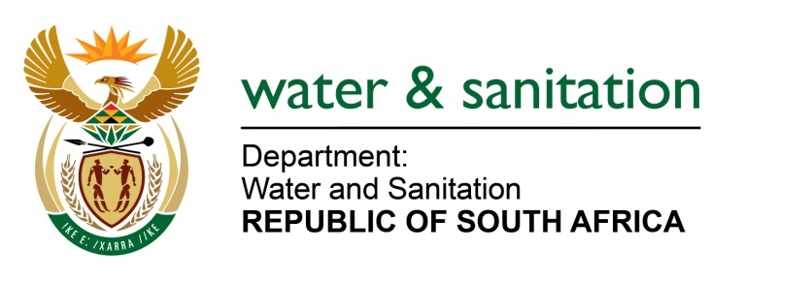

NATIONAL ASSEMBLY

FOR WRITTEN REPLY

QUESTION NO 1285

DATE OF PUBLICATION IN INTERNAL QUESTION PAPER: 1 APRIL 2022
(INTERNAL QUESTION PAPER NO. 13)

1285. Ms A M M Weber (DA) to ask the Minister of Water and Sanitation:

(1) Given the shocking destruction of the river ecology at the Wilge and Olifants Rivers in eMalahleni, Mpumalanga (details furnished), and the visit by his department at the Kromdraai Mine on Monday 14 March 2022 where there was a leak from a concrete seal filled with acid drainage mine water, what (a) are the reasons for the catchment management agencies not being in place for all the major catchment areas like Inkomati Usuthu Catchment Management agency, (b) are the names of all catchment management agencies that are being operationalised and (c) is the date on which each catchment management agency is envisaged to be operational;

(2) (a) on what date is it envisaged that the Olifants River Catchment Management Agency in Gauteng, Mpumalanga and Limpopo will be in place and (b) what has he found to be the reasons for the agency not being operational yet;

(3) whether there are any plans in place to build a wetland downstream from Kromdraai Dam in order to purify the water before it flows into the rivers; if not, why not; if so, what are the relevant details;

(4) whether he has found that the existing plant below Kromdraai Mine is active and sufficient; if not, why not; if so, whether he will furnish Ms A M M Weber with the reports of the PH levels, the toxic heavy metals, aluminium and salts like sulphates from which the water is purified?

NW1544E
---00O00---

MINISTER OF WATER AND SANITATION

(1)(a) The delay in the establishment of the Catchment Management Agencies (CMAs) has been for several reasons including (a) reconfiguration and realignment of all entities of the Department of Water and Sanitation in accordance with the Presidential report on the rationalisation of public entities; and (b) opposition to the establishment of new Agencies by labour unions as it is seen as privatisation

(1)(b) Breede-Olifants, Inkomati-Pongola, Mkuze-Mtamvuna, Vaal-Orange, Limpopo-Olifants and Mzimvubu-Tsitsikamma Catchment Management Agencies.

(1)(c) The Mkuze-Mtamvuna, Vaal-Orange, Limpopo-Olifants CMAs will be established by April 2023 and the Mzimvubu-Tsitsikamma CMA will be established by April 2024.

(2)(a) It is anticipated that the Olifants River Catchment Management Agency will be operational by April 2023

(2)(b) Due to reasons provided in 1(a) above, the Department changed its approach to the establishment of CMAs.

(3) The submitted action plan of 30 March 2022 proposed a passive treatment system (a wetland DongaLock system which is being evaluated by the Department’s wetland specialists. If approved, the system would be operational by September 2022.

(4) The existing dosing plant below Kromdraai Mine is active but is only partially treating the mine water as the sulphate quality limits are not being met. Measures will be implemented to continue with the improvement of the liming plant to the required design standard.

Regarding whether the department can provide the reports of the PH levels, the toxic heavy metals, aluminium and salts like sulphates to the Member, it should be noted that third party Information can be made available subject to a Promotion of Access to Information Act application.
---00O00---

