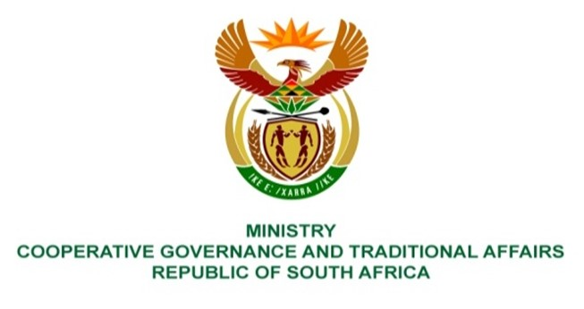

NATIONAL ASSEMBLY
QUESTION FOR WRITTEN REPLY

QUESTION NUMBER 1284
DATE OF PUBLICATION: 21 APRIL 2022

1284 Ms H O Mkhaliphi (EFF) to ask the Minister of Cooperative Governance and
Traditional Affairs:

Whether she has been informed that the Chris Hani District Municipality has been unable to collect revenue for services and that businesses are alleged to owe the specified municipality in excess of R10 billion; if not, what is the position in this regard; if so, what steps has she taken to ensure that the municipality has the necessary capacity to collect (a) revenue and/or (b) outstanding debts from (i) businesses and (ii) communities? NW1446
REPLY:
The the Municipal Manager of Chris Hani District Municipality provided the following table which represents the age analysis of the Chris Hani District Municipality as at 31 March 2023:
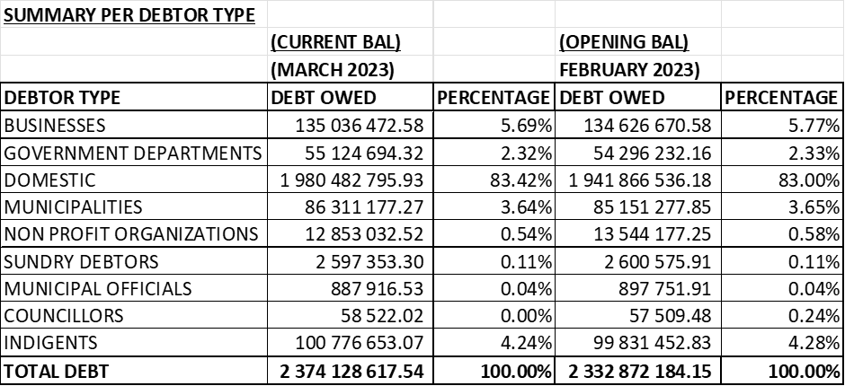

A. The municipality is owed by the consumers of its services an amount of R2,3 billion as at 31 March 2023 and of which the majority of the consumers that owe the municipality are domestic, businesses, indigents, municipalities and government departments.

There are notable slight decreases on businesses, government departments, municipalities, indigents, non-profits organisation, except the domestic consumers.

- The municipality has capacity in the Budget and Treasury Office, where there is a Revenue Unit which still has vacancies that are yet to be filled at the latest June 2023.
- The Municipality introduced a debt rehabilitation program that has been running for almost two years ending on the 30 June 2023. This is intended to assist the consumers with long outstanding debts. This was taken to the roadshows and the maximum assist is up to 50% write off for qualifying consumers.
- Indigent consumers of R98 million have been approved and the write-off was effected in April 2023. The reduction will be reflected in the May 2023 In-Year Monitoring Report.
- The Municipality has sourced a solution such as SMART Metering Water Meters that will be a phase approach that will focus more on businesses, government departments, schools, municipal areas and effluent areas etc. This solution will resume in beginning of May 2023.
- On the SMART Metering Water Meters Project, the focus will be more on the pre-paid solution in order to recoup the water revenues.
- Despite the strides of the municipality in trying to collect, there is a culture of non-payment including the government department.

- The municipality is issuing 14 days disconnection notices to all consumers except the households due to Constitutional imperative related to Human Rights. However, businesses, government departments (but not all, like clinics), are disconnected where there is non-payment.

- Payment arrangements are entered into, with all consumers, who responds to the disconnection notices and actual disconnections.

- Employees and Councillors, payment arrangements are revisited and are increased, and further disciplinary processes and code of conduct are implemented.

B) Chris Hani District Municipality total outstanding Debt as at 31 March 2023 an amount of R2,3 billion.

C) Businesses total outstanding Debt as at 31 March 2023 an amount of R135 million.

D) Remaining Total outstanding except the above, B and C.

End

