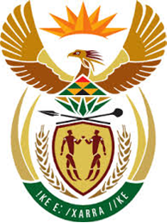

DEPARTMENT: PUBLIC ENTERPRISES
REPUBLIC OF SOUTH AFRICA
NATIONAL ASSEMBLY

QUESTION NO.: 1281
1281. Mr M G P Lekota (Cope) to ask the Minister of Public Enterprises:
Whether, given the perilous state of many state-owned enterprises (SOEs), he has found that any further financial support and guarantees from the Government will be required to ensure that the specified SOEs remain operational; if so, what are the relevant details of his policy projections in this regard? NW1381E

REPLY:

Response based on information received from DPE-Strategic Partnerships Unit.

The State Owned Enterprises within the Department of Public Enterprises (DPE) that have been given government guarantees (in compliance with PFMA) are Eskom, Transnet, Denel and South African Express (SAX). The government guarantee is limited to a maximum of R350 billion for Eskom, R3, 5 billion for Transnet, R2, 4 billion for Denel, and R0.8 billion for SAX.

Further financial support will be subject to SOEs providing a viable business case, clearly demonstrating that financial support will be utilized solely for advancing both commercial and developmental mandates. This will also be conditional on SOEs proving that they will adhere to prudent financial and risk management which will be closely monitored by the Department.

The form that financial support will take is subject to the Minister of Public Enterprises and Minister of Finance’s joint assessment and concurrence on each application received.

I believe that short to medium-term financial support (or guarantees) combined with changes in Boards and Management and a review of business strategies will be beneficial and fundamentally change the outlook for Sate owned Enterprises.

