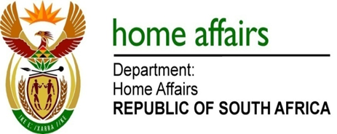

NATIONAL ASSEMBLY

QUESTION FOR WRITTEN REPLY

QUESTION NO. 1274

DATE OF PUBLICATION: THURSDAY, 26 APRIL 2018

INTERNAL QUESTION PAPER 13 OF 2018

1274. Mr M Waters (DA) to ask the Minister of Home Affairs:
Whether the Electoral Commission of South Africa paid any bonuses to any Commissioner in the (a) 2013-14, (b) 2014-15, (c) 2015-16 and (d) 2016-17 financial years; if not, what is the position in this regard; if so, (i) what amount was paid in each financial year, (ii) what is the name of each recipient of a bonus, (iii) who took the decision to pay such bonuses, provide minutes and (iv) what basis in law was this decision taken upon? NW1374E
REPLY:

(a) No
(b) No
(c) No
(d) No

There is no legal provision for bonuses as part of the conditions of service of Commissioners.

(i) Not applicable
(ii) Not applicable
(iii) Not applicable
(iv) Not applicable

