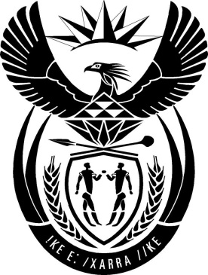

MINISTRY: PUBLIC SERVICE AND ADMINISTRATION

REPUBLIC OF SOUTH AFRICA

NATIONAL ASSEMBLY

QUESTION FOR WRITTEN REPLY

QUESTION NO.: 127.

Dr L A Schreiber (DA) to ask the Minister of Public Service and Administration:
(1) Whether his department’s Public Administration Ethics, Integrity and Disciplinary Technical Assistance Unit has been established; if not, by what date is it envisioned to be established; if so,
(2) whether he has found that the unit is (a) fully operational and (b) adequately staffed; if not, in each case, (i) why not and (ii) by what date will the specified unit be fully operational and adequately staffed; if so,
(3) whether the unit has conducted successful disciplinary processes against any officials yet; if not, why not; if so, what are the relevant details in each case? NW1088E

REPLY
- The Public Administration Ethics, Integrity and Disciplinary Technical Assistance Unit was established as per Public Administration Management Act Proclamation, effective from 1 April 2019.

- a) The Unit is not fully operational and b) it is not adequately staffed. (i) as the Department of Public Service and Administration (DPSA) has no funding to staff the unit or to allocate funds for its operations. (ii) The Unit is currently being incubated within the DPSA and is envaseged to be fully operational and adequately staffed by the next financial year, subject to the allocation of funds by the National Treasury.

- The Unit has not yet conducted any disciplinary process against officials as the Unit is not yet fully operational.

