NATIONAL ASSEMBLY

FOR WRITTEN REPLY

QUESTION NO. 1269

DATE OF PUBLICATION IN INTERNAL QUESTION PAPER: 01 APRIL 2022
(INTERNAL QUESTION PAPER NO. 13)

Mrs M O Clarke (DA) to ask the Minister of Health:

(1) (a) What is the total number of (i) foetal and (ii) maternal deaths that have occurred in (aa) each State hospital and (bb) private health facility in the past five years, (b) which of the specified hospitals had the highest number of deaths and (c) what is the breakdown of the specified deaths in each province;
(2) whether his department has identified the reasons for the deaths in each case; if not, why not; if so, what are the causes?

NW1527E
REPLY:
- (a)-(b) The attached Annexures provide the details in this regard.

- Causes of foetal deaths

According to the Saving Babies Report 2017-2019 (pg 13-14) the following are the causes of foetal deaths
- Hypoxia
- Infection
- Congenital abnormalities
- Immaturity related causes
Causes of maternal deaths

According to the Saving Mothers Report 2017-2019 (Pg-20, 80-83), and Impact of COVID-19 on maternal health Report 2021 the following were the causes
- Non-Pregnancy related infections related to HIV
- Hypertensive disorders of pregnancy
- Medical and surgical disorders
- Obstetric Hemorrhages
- Miscarriages and Ectopic pregnancies
- Pregnancy related sepsis

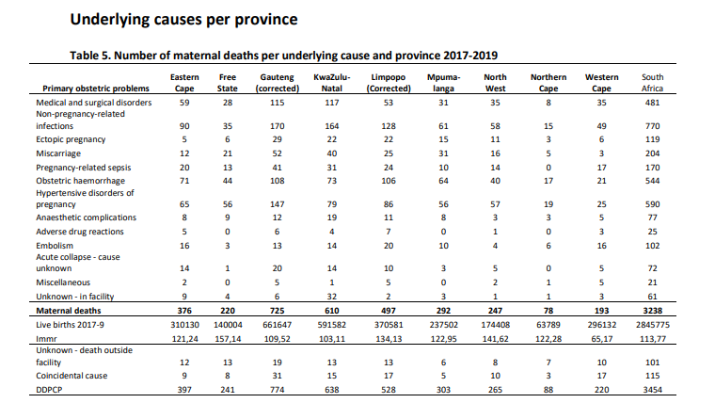
Source: Saving Mothers Report 2017/19, Pages 20.

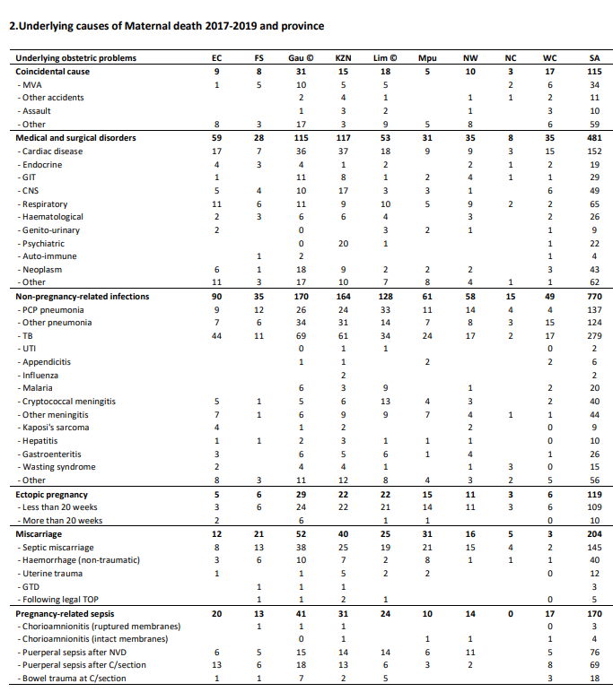END.

