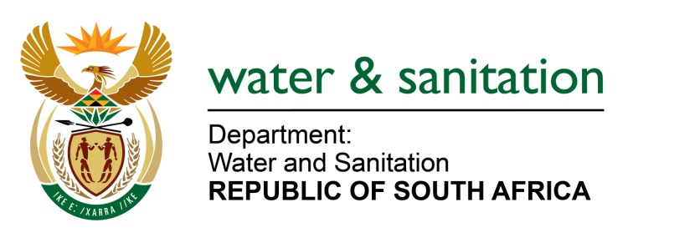

NATIONAL ASSEMBLY

FOR WRITTEN REPLY

QUESTION NO 1267

DATE OF PUBLICATION IN INTERNAL QUESTION PAPER: 31 MARCH 2023
(INTERNAL QUESTION PAPER NO. 12)

1267. Mr M G E Hendricks (Al Jamah-Ah) to ask the Minister of Water and Sanitation:

(1) Whether he has been informed of complaints of dangerous mining chemicals which are polluting the water stream and the environment in areas such as the Wonderfontein Catchment Area in the Merafong City Local Municipality; if not, why not; if so, what are the relevant details;

(2) whether he has been informed of allegations that some government officials and politicians are colluding with mining bosses responsible for polluting the waterways; if not, why not; if so,

(3) whether any of the implicated government officials and politicians have been investigated; if not, why not; if so, what are the relevant details;

(4) whether any steps will be taken to stop residents in Potchefstroom and Ventersdorp from drinking the polluted water and catching fish from there; if not, why not; if so, what steps?

NW1410E
---00O00---
MINISTER OF WATER AND SANITATION
- No, my department is not aware of any complaints pertaining to dangerous mining chemicals polluting a water stream and the environment in the Wonderfontein Catchment Area. However, there are various platforms available to report such incidents through the DWS Hotline 0800 200 200 or via email: customercare@dws.gov.za or directly to officials (whose contact details are also on the internet webpage under customer care www.dws.gov.za responsible for the catchment area). Specific details pertaining to this question will be appreciated and investigated once received.

- No, my department is not aware of any allegations that some government officials and politicians are colluding with mining bosses to pollute waterways. However, should there be such allegations, they must be reported to enable the department to investigate.

- No, there is currently no official of my departmental being investigated regarding allegations of collusion with mining bosses.

- Current routine monitoring results do not indicate any pollution incidents in this area. Anomalies detected in water quality would normally also be relayed to the local municipality so that the information is publicised through local radio stations and newspapers if necessary.

The JB Marks Local Municipality (under which the towns of Potchefstroom and Ventersdorp falls) implements a Water Safety Plan, which is aimed at identification and prioritisation of risks associated with water supply. In line with this plan, the municipality identifies risks associated and encountered at the catchment, treatment and distribution network and employ mitigation measures to ensure water supplied is safe for human consumption. The municipality has reported that it has not detected any irregularities in the catchment.

Areas under the jurisdiction of JB Marks Local Municipality receive treated water with a microbiological compliance for the year to date at 94.5% (when measured against SANS241 limits).
---00O00---

